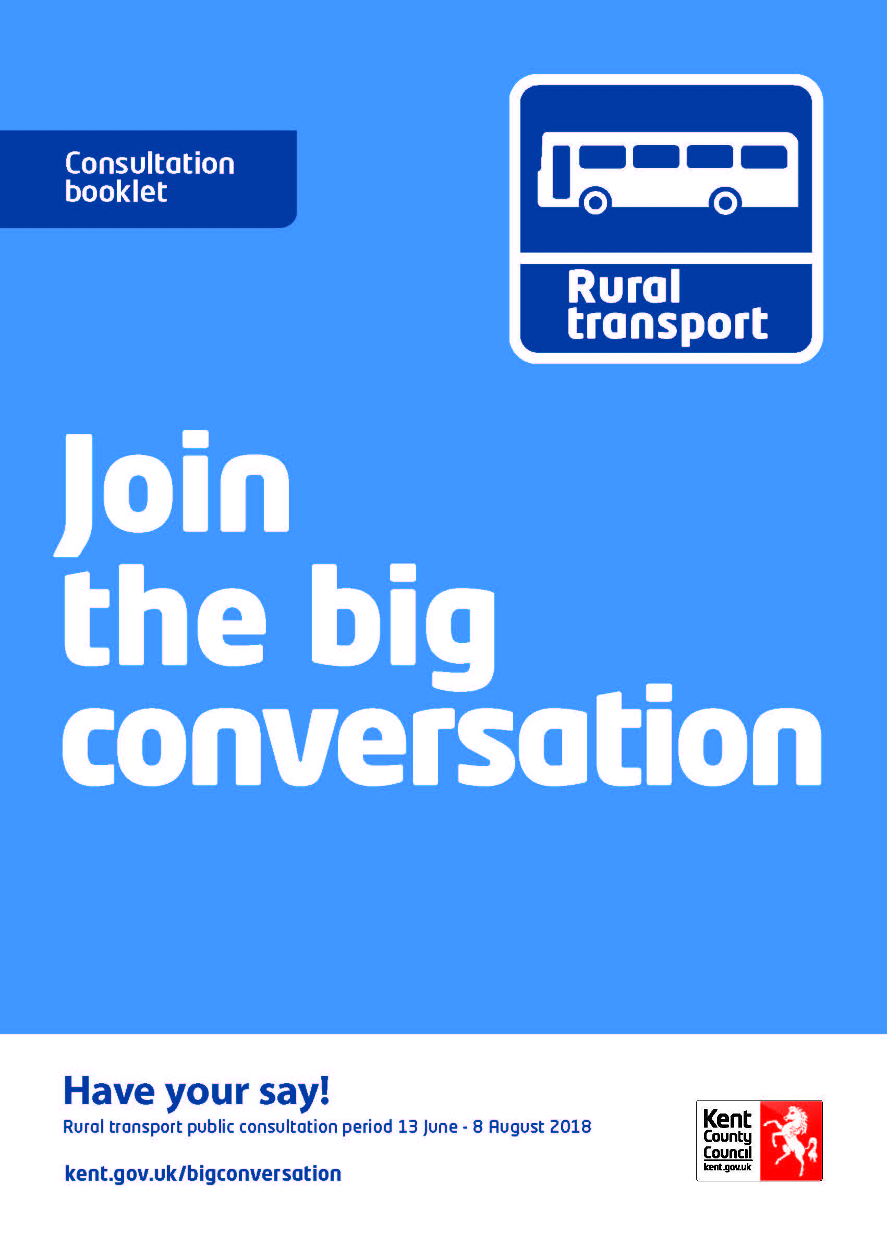

Big Conversation on rural transport in Kent

Contents
1. Introduction 1
2. Our support for public transport in Kent 3
3. What do we hope to achieve? 5
4. Potential ideas for the future 6
5. How to get involved and have your say 12
Glossary of terms 15

Welcome to the Big Conversation on rural transport in Kent

1. Introduction
What is the Big Conversation? We want to find out if there is a better, more sustainable way of providing transport to rural communities not currently served by commercial operators. We want to explore ideas in conversation with you.

We are working with transport and technology providers, Parish and Town Councils, stakeholder organisations and communities across Kent to identify potential new ways of delivering rural transport.

Kent County Council (KCC) issues over 252,000 concessionary travel bus passes for elderly and disabled residents as well as helping to transport 32,000 young people through our unique young person’s and 16+ travel bus pass.

Around 97% of journeys in Kent are run without public subsidy by private operators (such as Arriva and Stagecoach) – with over 50 operators covering 600 services. But not all of Kent’s bus services are run in this way. Over the last 30 years KCC has funded routes which, while not commercially viable, have been considered important to meet the needs of the communities and residents.

In this document we:
- Provide background information on how we, as a Council, support public transport in Kent.
- Identify what we hope to achieve through this conversation.
- Tell you about our first thoughts on possible new ways to provide rural transport.
- And most importantly ask you for your views and thoughts.

The document contains some terms that you may be unfamiliar with, therefore a glossary has been provided at the end to give further explanation.

2. Our support for public transport in Kent
KCC has a role in supporting residents accessing education, health and community services. We know that our transport services are essential for some Kent residents as they provide vital links to other services.

As a Local Transport Authority, we have a duty to consider funding bus services that are not provided commercially. These are services which are considered important to the communities and residents they serve and provide transport links to key services that could not otherwise be accessed.

KCC spent £64.2m last year on providing transport services or subsidising the cost of travel for bus users. This is summarised below:

In addition, Kent has good examples of community provided transport. These offer a valuable service for residents either instead of or in addition to other transport services. KCC can offer one-off funding and support to Parish Councils or other organisations to help get schemes off the ground.

3. What do we hope to achieve?
Against a backdrop of ever decreasing funding for local councils, we want to maintain and, where possible, improve rural accessibility for those without alternative means of travel. Helping to tackle social isolation and provide the “right transport solution for the right customer need, at the right price”.

To do this we want to:
- Make better use of existing transport resources.
- Integrate services with the wider commercial transport network.
- Help to protect future services.
- Make best use of technology.
- Work with our partners and communities to find the best solutions.

The Big Conversation focuses on future delivery of rural transport and is not considering any changes to the current Special Educational Needs (SEN) transport arrangements.

4. Potential ideas for the future
We have been working with transport providers and partners to develop some initial ideas which could protect future services and potentially provide new rural links.

These ideas build on the experience of our public transport team and transport providers and consider what could work in Kent, as well as what has worked elsewhere.

The following ideas could provide an alternative way to support rural transport by replacing routes and journeys currently subsidised by KCC. It is important to highlight that these ideas are at an early stage and we have not investigated making changes to specific services or areas of the county.

We are aware that one idea may not be suitable for all communities, so we may choose to explore different ideas in different locations across the county. Due to the broad scope of these ideas, they have not been costed and we are keen to seek your views before progressing any further.

Our initial ideas seek to provide a more sustainable and improved service. We envisage any pilots to be funded through a combination of KCC funding and ticket income; this might involve the need for those passengers who have a concessionary pass to contribute to the cost of some of their journeys.

Following the closure of the consultation we will use your feedback to help explore these ideas before refining proposals for the Bus Summit in October 2018. If approved, pilots could be put into action in the first half of 2019.

We want your views on these ideas to ensure that we fully understand your needs, concerns and preferences.

Idea 1: Feeder services
For some rural communities it may be possible to provide feeder services, using either a small bus or a taxi to provide a service which would connect rural communities with an existing commercial bus service for the onward journey.

Feeder services would be timetabled with convenient stops along the route and would have a reliable connection with an existing commercial bus service. They would connect with the existing commercial bus both going to and returning from a destination. For example, a small minibus serving three villages connects with Bus A four times a day and does the same for the return journey.

These new connections would be made either at an existing bus stop or a newly created one. Passengers could wait on the feeder vehicle for their connecting bus to arrive.

We envisage the users being able to purchase a ticket that could cover the whole journey (feeder service and existing bus service).

Comparison to current rural bus service
Advantages | Disadvantages
More regular journey opportunities | Loss of direct journey
Potential to connect more communities to the commercial network | Passengers are required to change from one vehicle to another
Retains a set timetable | Potentially longer journey time

Idea 2: Bookable flexible bus services
In some rural areas it may be possible to provide a bookable bus service using small vehicles such as minibuses.

A bookable bus service would collect passengers from designated points within a community and could be used to access a range of destinations in a given area. This could range from a single point or pick up from home.

Passengers would make a booking via phone or internet, provide journey details and the service would inform them of when they could be picked up for their journey. Bookings could be made seven days, one day or even hours in advance.

Such a service would bring together all the bookings in a given area to make the journeys as efficient as possible. Therefore, passengers would need to be flexible with the time and length of their journey. Additional time will need to be allowed for fixed time appointments e.g. doctor’s appointment.

Bookable buses are used in other parts of the UK to provide rural communities with a bus service. This could mean the needs of residents can be tailored for a local community. However, where appropriate, journeys will be shared.

There are number of possibilities for how bookings could be made, for example, by telephone, mobile app and online.

Comparison to current rural bus service
Advantages | Disadvantages
Provides greater journey opportunities | Potentially longer journey time
Is available on demand | Passengers will need to book
Enables improved access to customer demanded locations | Booking times are combined, so passengers will need to be flexible

Idea 3: Use of taxi-bus style services instead of a bus
KCC makes significant use of taxis as part of its network of home to school transport and there is an opportunity to make greater use of these vehicles. There is the potential for KCC to work with its operators to provide rural taxi-bus services.

Instead of a bus or as a new transport link, there could be a taxi-bus - a smaller vehicle, such as people carrier or minibus. The taxi-bus would run to an agreed timetable and route and would stop at agreed points in each community it serves.

In order to better cater for the low numbers traveling, the taxi-bus, like a normal bus service, would charge individual fares for different journeys along the route and would accept a range of payment methods (cash and card).

Comparison to current rural bus service
Advantages | Disadvantages
Retains a set timetable | Smaller vehicle may require some users with accessibility requirements, such as wheelchair users, to book in advance
May be possible to retain existing routes | Capacity of vehicle limits number of users per trip

Key features of the three ideas:
 | 1. Feeder services | 2. Bookable flexible bus services | 3. Taxi-bus style services
Frequency | Timetabled | Changes based on bookings with more flexible pick up points | Timetabled
Destination | Connecting service | Variable (within set options) | Fixed
Journey length and time | Fixed but longer than a direct service | Will change dependent on combined bookings | Fixed
Booking | Not required | Advance booking via the phone or internet required | Not required
Changing vehicles | Must change with guaranteed onward connection at a bus stop | Not required | Not required

Each of these ideas could be provided by KCC or a commercial/community transport operator.

5. How to get involved and have your say
Your feedback is really important. It will be used along with feedback from bus, community transport and taxi operators and our equality analysis to develop potential pilots that will be presented at a Bus Summit in October 2018.

We particularly want to hear your views on:
- Your usage of public transport and the journeys you make.
- What your priorities are for a sustainable rural transport service.
- Feedback on the three initial ideas we have developed.
- Any additional information you think we need to consider when shaping the services for the future.

Tell us what you think by completing our questionnaire online at www.kent.gov.uk/bigconversation.

Paper copies are available from Kent Libraries and Gateways (visit www.kent.gov.uk to find your nearest one) or on request (details below).

A copy of our initial Equality Impact Assessment (EqIA) is available at www.kent.gov.uk/bigconversation or on request (details below). This document aims to identify any impacts, both positive and negative, that could result from the ideas we are exploring on any of the protected characteristics (age, disability, gender, gender reassignment, sexual orientation, race, religion, and carer’s responsibilities).

As part of this process, we are hosting 11 public meetings across Kent between 7pm and 9pm. We will be presenting our initial ideas and providing opportunities for you to ask our team any questions you have.

Public meeting venue | Date
Dover Town Hall  The Maison Dieu, Biggin Street, Dover CT16 1DL | Tuesday 19 June
Margate Football Club  Hartsdown Park, Hartsdown Road, Margate CT9 5QZ | Thursday 21 June
Elite Venue Centre  Dunkirk Close, Gravesend DA12 5ND | Tuesday 26 June
Stag Community Arts Centre  London Road, Sevenoaks TN13 1ZZ | Wednesday 4 July
Borough Green Village Hall  Borough Green TN15 8DG | Thursday 5 July
University of Kent  Darwin Conference Suite, Canterbury CT2 7NZ | Tuesday 10 July
The High Weald Academy  Angley Road, Cranbrook TN17 2PJ | Wednesday 11 July
St Mary’s Bay Village Hall  Romney Marsh TN29 0SW | Thursday 12 July
Homewood School & Sixth Form Centre  Ashford Road, Tenterden TN30 6LT | Tuesday 17 July
UK P Leisure  Avenue of Remembrance, Sittingbourne ME10 4DE | Wednesday 18 July
Sessions House  Lecture Theatre, County Hall, Maidstone ME14 1XQ | Thursday 19 July

The presentations will be available on our website. If you have any questions and can’t make the public meeting, you can contact us on bigconversation@kent.gov.uk

This part of the Big Conversation runs for eight weeks from 13 June until 8 August 2018 (inclusive).

An Easy Read version of this document and the questionnaire is available on our website www.kent.gov.uk/bigconversation or upon request.

To request hard copies of any of the consultation documents or for any alternative formats, please email alternativeformats@kent.gov.uk or telephone on 03000 421553 (text relay service 18001 03000 421553). This number goes to an answer machine, which is monitored during office hours.
Glossary of terms
Commercial Operators: A licensed transport operator providing services as their main business with the aim of generating a profit.
Community Transport Operators: means non-commercial operators who have a different license to the likes of Arriva and Stagecoach. These operators are typically more voluntary in their nature and can often provide transport services for the Council at a lesser cost.
English National Concessionary Travel Scheme: means the older person’s bus pass. KCC has to pay operators for each journey made by the pass holder.
Equality Impact Assessment: means the assessments carried out by Council officers to understand the impact of proposed changes on existing bus users based on their protected characteristics. These are: age, disability, gender, gender identity, race, religion or belief, sexual orientation, pregnancy and maternity, marriage and civil partnership and carers’ responsibilities.
Kent Karrier: means the KCC dial-a-ride services which provide door to door transport for older people and disabled members and for rural communities that do not have a bus or train service.
Local Transport Authority: means the local government organisation with responsibility for local transport (roads, drainage, public transport etc.) matters. In this instance, this means Kent County Council.
Bus Service: means a conventional public bus service which is available to any passenger wishing to pay a fare or carrying a valid pass. This does not include 20 ‘Hired’ services used specifically to carry particular groups such as school coaches and minibuses.
Subsidised: means payments made by the Council to bus operators to help them operate services that are not commercially viable because of low passenger usage but that the Council wants to see operated because they are important for bus passengers.
Young Person’s Travel Pass: means KCC’s scheme that provides reduced cost bus travel for secondary aged school children. KCC has to pay operators for each journey made by pass holders.
The Kent 16+ Travel Card: means KCC’s scheme that provides reduced cost bus travel for those who are post 16 and up to the age of 18 accessing education or training. KCC has to pay operators for each journey made by pass holders.

