‘Your Future, Our Priority’

Kent County Council’s 5 Year Strategic Plan 2020-25
Consultation draft and questions – easy read version

Making Kent the best place to live, work, play, learn and invest in

Hello,

We (Kent County Council) would like to tell you about our draft 5 year plan.

This plan tells you what we would like to make happen in Kent.

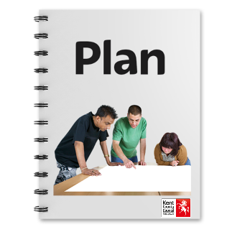
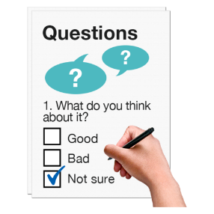 | We would like to know what you think of this plan (this is called a consultation).  You can do this by answering the questions at the end.  If you would like a paper copy please ask us by emailing PSRPolicy@kent.gov.uk or telephone 03000 416788. We can send out a pre-paid envelope so you can return this to us.  The consultation runs from  6 January to 17 February 2020.
This is an easy read version of the strategy. It gives you an idea of our plans. But there is much more in the full strategy. There is also a full version of the questions.

These are on our website at: www.kent.gov.uk/5yearplan

Some words have been put in bold, these have been added to the glossary at the end of the document.

Introduction
Facts about Kent

Kent is a county to be proud of. We have history, countryside and a good economy.

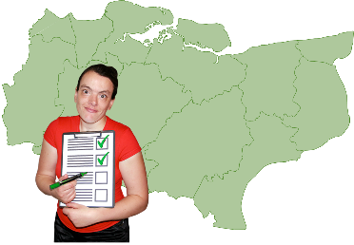 | We have these strengths:  - We are close to London and our residents can access opportunities from the capital  - We have 3,011 voluntary organisations and 2,000 social enterprises  - 91% of schools are rated good or outstanding  - We have good road, rail and port connections  - We have a beautiful natural environment with lots of green and open space  - 90% of businesses are small to medium sized with unemployment below the national average. We also have many businesses working in the countryside (rural areas)  - We have a great coast, countryside and creativity  - We are a producer of fine food and drink.
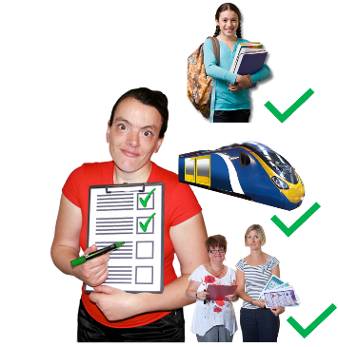
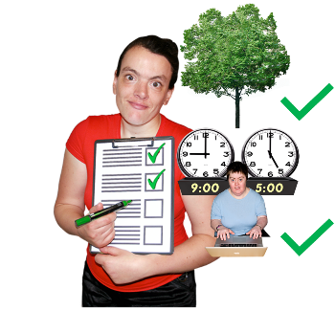
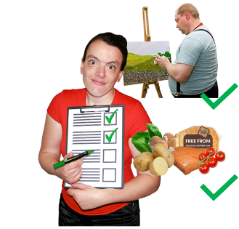
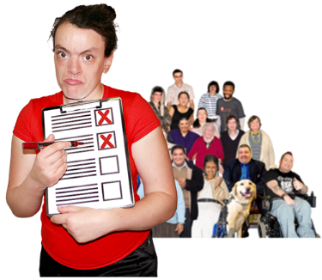 | But we have these challenges:  - We have a growing population – meaning more demand for services  - We need many new homes– meaning more demand on infrastructure  - More lorries are using our roads  - We need to do more to support climate resilience, preparing for severe weather and flooding  - Unemployment for the young is above the national average  - There are pressures on children’s social care  - We need more school places  - Disruption caused by Brexit.
Our outcomes

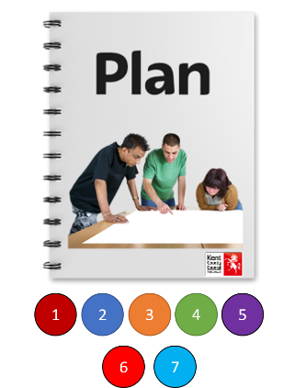 | There are 7 parts, or outcomes in this draft 5 year plan. These explain what we would like to do over the next 5 years.  We introduce the outcomes below before going into more detail.
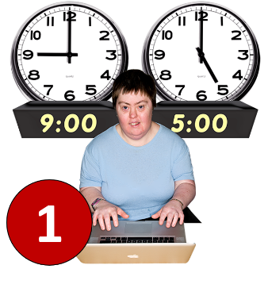 | Outcome 1 - Enterprise and Investment  We want to help people and businesses to do well. We want more good jobs in Kent and for people to have the skills they need.
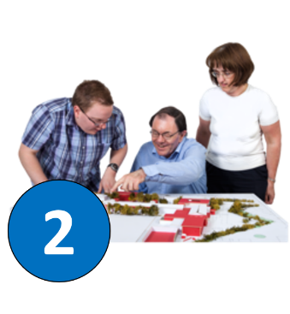 | Outcome 2 - Securing sustainable infrastructure  We want to make sure that the local area has the facilities that people need.
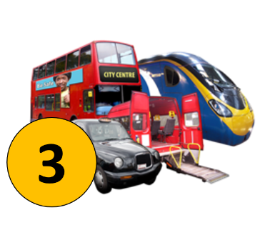 | Outcome 3 - Connected transport and communities  We want people to have the same chances across our county. We want to have good quality roads and public transport which is joined up and easy to use.
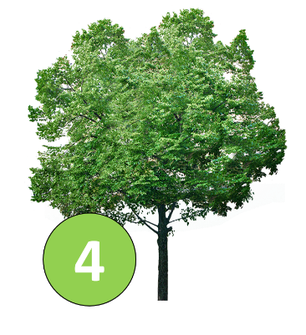 | Outcome 4 - A cleaner and greener Kent  This is about looking after our environment. This includes parks, paths and the countryside. We will work to clean up the environment and cut greenhouse gases and pollution.
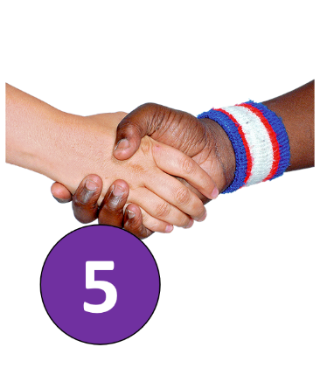 | Outcome 5 - Stronger and safer Kent communities  Everyone should feel safe in their community. We will work with other organisations to improve services. We want people to feel part of, and safe within their local areas.
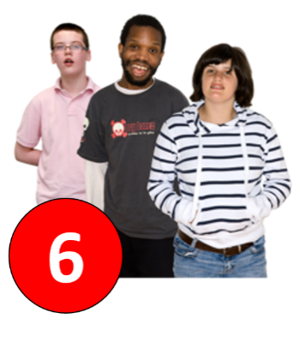 | Outcome 6 - Opportunities for children and young people  Making sure that children and young people in Kent have the best possible futures. We want them to be healthy and happy, to get a good education and the skills they need.
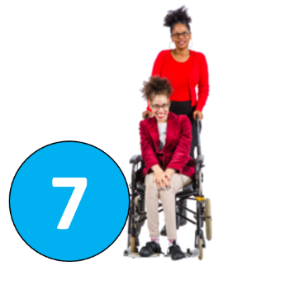 | Outcome 7 - Quality care and support  We want people to have healthy, happy lives. This means looking after their physical and mental health.
About each outcome

Outcome 1 – Enterprise and Investment

We want to help people and businesses to do well. We want more good jobs in Kent and for people to have the skills they need.

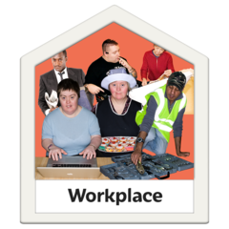 | We want to do more to make Kent a great place to live and work. To do this we need to make sure there are good jobs, houses that people can afford and successful businesses.
 | Working with partners we will help people to develop their skills so they can find a good job in Kent. We want to make sure there is training available that is right for everyone, including apprenticeships.
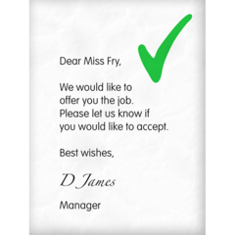 | We want people to have jobs that value their skills and give them opportunities for the future. We want businesses to create great job opportunities for people, particularly in areas where less jobs are available.
 | We will continue to support Kent’s business. We want to make sure that businesses can find employees with the skills they need.
 | We want to encourage businesses and people who work for KCC to make the most of new technology and better ways of doing things.
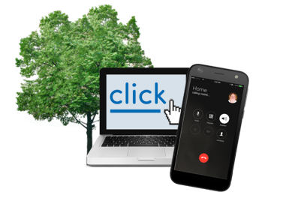 | We want businesses in Kent’s rural areas (in the countryside) to do well. We want to help them get good internet and mobile phone coverage.
Outcome 2 – Securing sustainable infrastructure

We want to make sure that the local area has the facilities that people need.

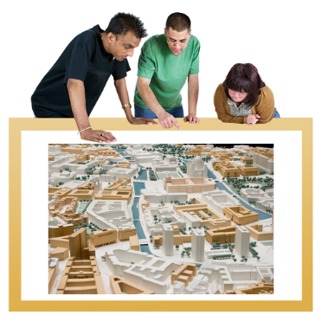 | As more people move to Kent and people are living for longer, we face challenges providing the facilities which people need to live their lives. We will work to make sure that communities have the facilities they need, like education, transport, the internet and health services.
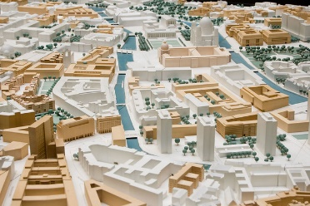 | We will work with our partners and developers to make sure that we have the infrastructure we need.
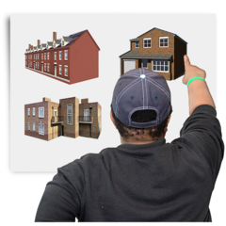 | We will support the creation of vibrant, well-designed communities and homes that people are proud to live in. These must be affordable.
 | We are working on a new ‘Kent Design Guide’ to set out how building should happen. This includes making sure we still have green outside spaces for people and nature. We will work with developers to regenerate towns.
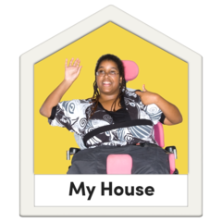 | We will plan and deliver Extra Care housing for people with social care needs. This housing will help them live a good life.
 | We will work with companies on their long-term plans. This will make sure we have energy, water and waste management for our communities.
 | We will work to ensure that people have access to high speed internet.
Outcome 3 - Connected transport and communities

We want people to have the same chances across our county. We want to have good quality roads and public transport which is joined up and easy to use.

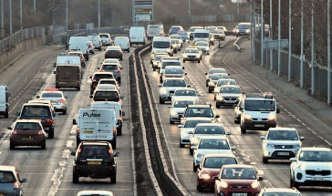 | Being close to Europe means that Kent’s roads are particularly busy and important.
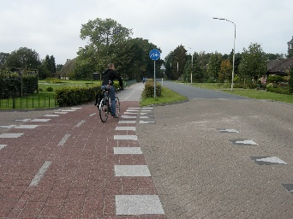 | It is important that our roads and pavements are in good condition, and when we talked to people about what mattered to them the most, they often talked about this. We want to make sure that traffic keeps moving so people can get around the county.
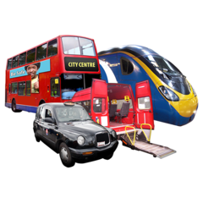 | We will work with other organisations to improve train travel and make sure that bus services are affordable, reliable and frequent. This is very important to help people get to and from work, for leisure and to make sure that people do not get isolated.
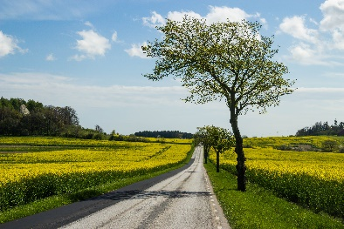 | Kent has lots of roads in the countryside and we will ensure that these are well maintained.
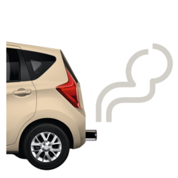 | People have told us that they are worried about clean air and road safety. To help support this we will encourage people to use active travel options, such as walking and using a bike.
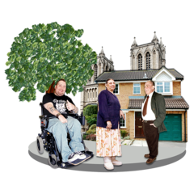 | People have told us that services must be fair, and that wherever you live you must have good access to services. We want everyone in Kent to feel part of their community and to be able to stay connected to other people.
Outcome 4 – A cleaner and greener Kent

This is about looking after our environment. This includes parks, paths and the countryside. We will work to clean up the environment and cut greenhouse gases and pollution.

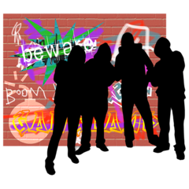 | People have told us they want to live in places that are well looked after and clean so they can feel proud to live there.  We will work with our partners to reduce graffiti, litter, help people recycle more and reduce waste. We have already invested £250,000 to stop people dumping rubbish (fly tipping).
 | We want to protect the environment by working with our partners and taking the lead on this issue. We recognise the importance of green and open spaces, paths and natural areas to support people’s health and wellbeing.
 | As Kent grows, we have an important role to make sure that growth happens in an environmentally friendly way. We are aiming to have zero carbon emissions by 2050. We formally acknowledge the climate emergency. We have already achieved some of our targets and will continue to do work on reducing pollution.
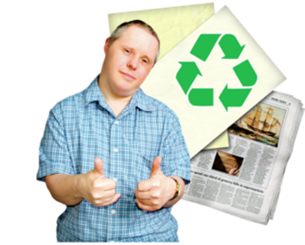 | We have a strong relationship with businesses and we will work with them to promote the green (environmental) economy. This includes making the most of new green technologies and encouraging environmental responsibility.
Outcome 5 – Stronger and safer Kent communities

Everyone should feel safe in their community. We will work with other organisations to improve services. We want people to feel part of, and safe within their local areas.

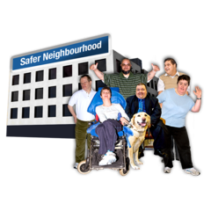 | It is important that people feel involved and safe in the place that they live. We want communities to work together and solve problems to help others. We will support communities to help this to happen.  We are developing a ‘Civil Society Strategy’. This aims to build relationships between communities and voluntary groups. This will bring people together to do local projects, tackle social isolation and strengthen community resilience.
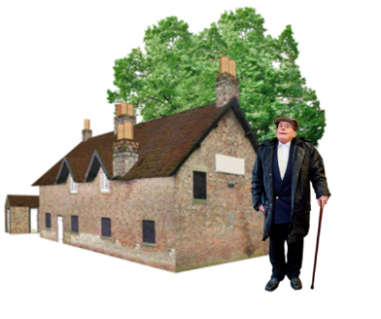 | There are sometimes particular challenges for communities in rural areas and we will develop a ‘Rural Strategy’ to explain how KCC will help these areas do well.
 | We work in partnership with Kent Police, Kent Fire and Rescue and others to reduce crime, anti-social behaviour and abuse. We will spend more money on Community Wardens to help local areas stay safe.
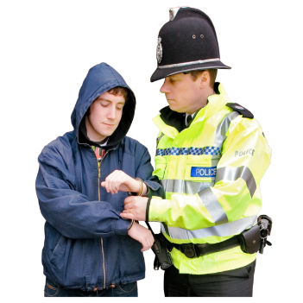 | We are working with national and local partners on serious issues such as gangs, knife crime and drugs. We will continue to do this as part of a ‘multi-agency’ operation across the county to tackle these and other serious issues.
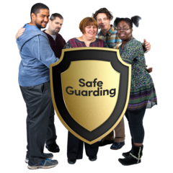 | One of our important responsibilities is to keep children and adults safe from abuse, harm and neglect. We’re working with our partners to improve this.
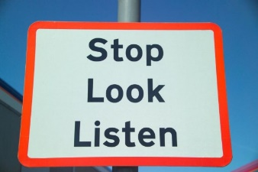 | We want to make sure that everyone can travel safely on Kent’s roads and pavements.
Outcome 6 – Opportunities for children and young people

Making sure that children and young people in Kent have the best possible futures. We want them to be healthy and happy, to get a good education and the skills they need.

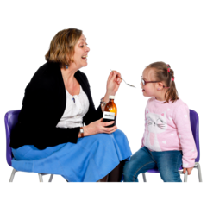 | We want to make sure that all children have the best start. Our health visiting service supports parents during pregnancy and after. We work with our partners to make sure children are healthy during their first years.
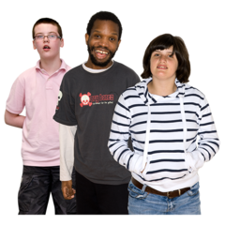 | Our services with partners help children and families who need extra support. As a corporate parent we will look after children and young people in our care.
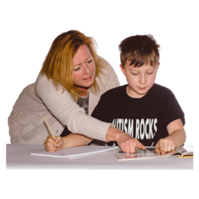 | We have many good schools in Kent. We will work with schools and other partners to make sure people have a choice of good quality school places for their children.
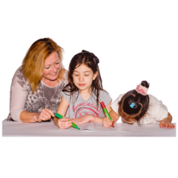 | We will improve our Special Educational Needs and Disabilities services.
 | We will improve mental health services so that young people are able to access the right support at the right time. We want to prevent young people from having mental health problems where possible.
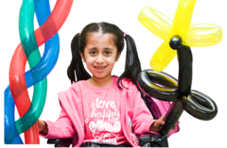 | We want to work with partners and communities to provide a youth offer of fun activities for young people to do.
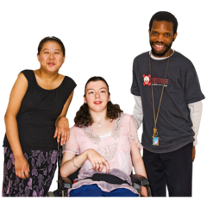 | We will work to ensure that young people have the right skills for a good life in Kent.
Outcome 7 - Quality care and support

We want people to have healthy, happy lives. This means looking after their physical and mental health.

 | We want to support a happy and healthy society in Kent, with good health and wellbeing at every stage of life. We call this ‘living well.’
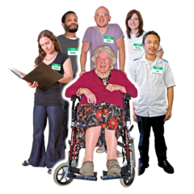 | We will work on making sure everyone has access to good health and social care across Kent. We will continue to focus on prevention to help people feel and stay well. We will work on tackling social isolation and loneliness.
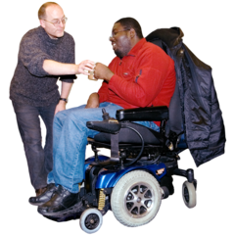 | We will support and protect the most vulnerable adults. We have worked to deliver health and social care with our partners and other organisations, and we will continue to ask Government for fair funding for everyone who needs social care.
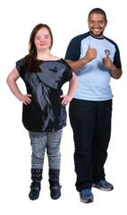 | We will continue to promote independence (through Local Care) and make the most of new technology where this supports care within the community. When people have health or social care needs, they need quality care, at the right time, in the right place.
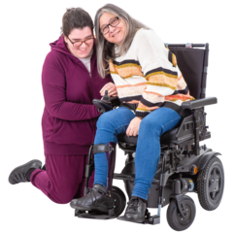 | We value the hard work of carers (including young carers). We will make it easier for carers to access the information, advice and the guidance they need, and make sure that carers are supported and can have breaks.
 | We now manage mental health services. This means we can join up our services better to make sure people have support when they need it in the right place.
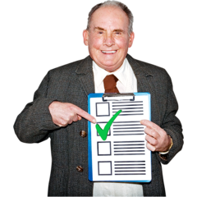 | How will we check we are keeping to our plans?  We will:  - Check if our funding has made improvements  - Have checks 4 times a year on what we are delivering  - Look at evidence in our communities and measure this  - Look at how things have changed over time  - Ask residents and service users so we understand their experience.
Conclusion

We hope you have enjoyed reading about our plans.

Please tell us what you think by answering our questions below.

What you tell us will make a difference. We will look carefully at what people have said and use it to improve our draft. We will publish a “You said, We did” report which will summarise the feedback we have had.

The final documents will be published at www.kent.gov.uk/5yearplan

If you would like this document in another format or language, please email:

Alternativeformats@kent.gov.uk

or call 03000 421553. Text relay 18001 03000 421553.

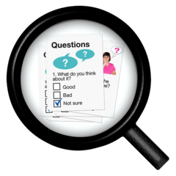
Glossary

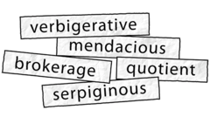 | A glossary is a list of tricky words.
 | Climate resilience – being prepared for changes linked to climate change, such as more extreme weather or flooding
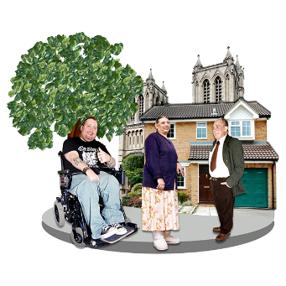 | Community reliance – for communities to work together, so that people are able to support each other.
 | Corporate parent – KCC has responsibility to provide the best possible care to children in care
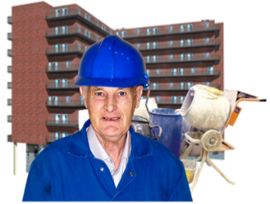 | Developers – companies who build housing
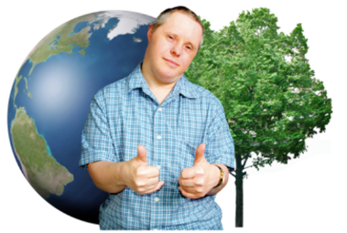 | Environmental responsibility – working in a way which protects the environment
 | Local care – People being able to get health and social care advice and services in their local community
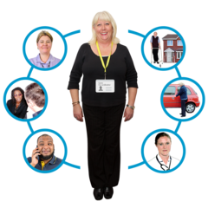 | Multi agency – different organisations working together
 | Social enterprises – businesses with a social or environmental mission
 | Special educational needs – this might be a learning difficulty or a disability which makes learning more challenging.
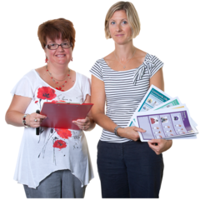 | Voluntary organisations – a group of people working together to work towards a purpose. These are often volunteers
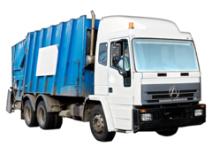 | Waste management – activities required to manage rubbish
 | Zero carbon emissions – balancing the carbon we produce with the carbon we remove from the air

Please tell us what you think

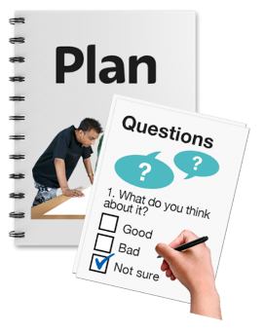 |  |  |  | Now that you have read our draft 5 year plan, we would like to know what you think of it.  Please answer these questions. You do not have to answer them all if you do not want to.
If you would like to fill in this questionnaire you can return this to us by post.

Room 2.70
Kent County Council
Sessions House
Maidstone
ME14 1XQ

If you would like a paper copy please ask us by emailing PSRPolicy@kent.gov.uk or telephone 03000 416788. We can send out a pre-paid envelope so you can return this to us.

You can do this from the 6 January until the 17 February 2020.

If you need the questions in a different format, please email alternativeformats@kent.gov.uk
or call 03000 421553

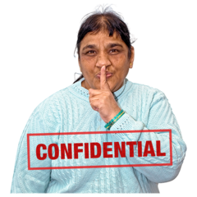 |  |  |  | Privacy KCC will keep your personal information to help us give you the services you need. But there are laws about how we use your personal information, and we will always do as they say.  You can read more about them on https://www.kent.gov.uk/about-the-council/about-the-website/privacy-statement
Questions
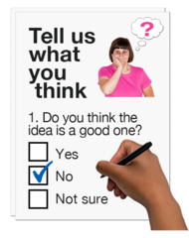 |  | 1. Please tick the box that describes why you are responding to this consultation.  Are you:
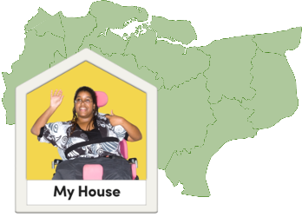 |  | ☐ |  |  | Someone who lives in Kent
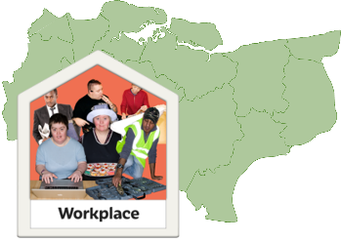 |  | ☐ |  |  | Someone who works in Kent
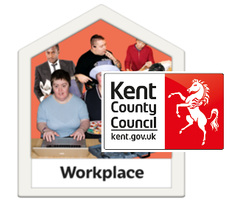 |  | ☐ |  |  | Someone who works at Kent County Council
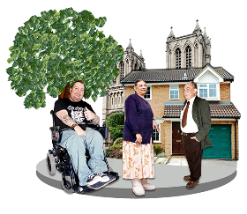 |  | ☐ |  |  | A representative of a business, community group or organisation
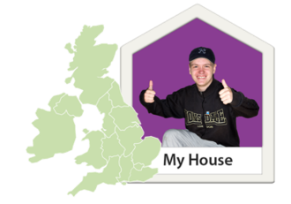 |  | ☐ |  |  | A resident from somewhere else, such as Medway
 |  | ☐ |  |  | Other - please tell us here:
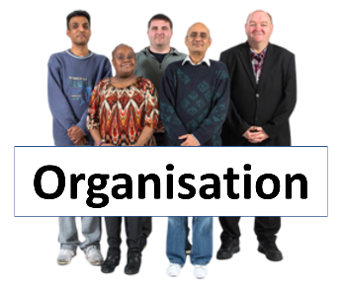 |  | 1 (a). If you are filing in this form for an organisation please tell us its name here:
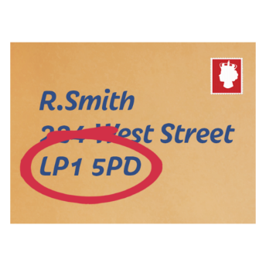 |  | 2. What are the first 4 letters or numbers in your post code (please don’t give us your full post code). This information is used to help with our analysis and is not used to identify you.
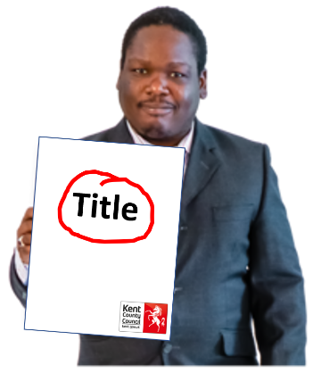 |  |  | 3. The draft title of the 5 year plan is ‘Your Future, Our Priority’  Do you like the draft title? Tick one box only.  Yes ☐  No ☐  Please tell us if you have any ideas for the title below:
4. We want to make people’s lives in Kent better. We’ve talked to lots of people who live and work in Kent to find out what is important to them.

There are 7 parts, or outcomes in this draft 5 year plan. These explain what we would like to do over the next 5 years.

Will the outcomes help you live a better life?

Please tick one box only.

 |  |  | ☐ |  |  | Yes
 |  |  | ☐ |  |  | No (please tell us why you think this in the box below)
 |  |  | ☐ |  |  | In part (please tell us why you think this in the box below)
 |  |  | ☐ |  |  | Don’t know
 |  |  | Please tell us why in this box:
 |  |  | 5. Are we talking about things that are important to you in the outcomes?
Outcome

Enterprise and investment  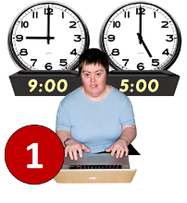 |  |  | Yes  ☐ |  |  |  |  | No  ☐ | Don’t know  ☐
 |  |  | Please write any comments here:
Securing sustainable infrastructure  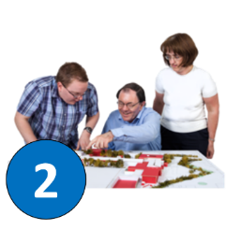 |  |  | Yes  ☐ |  |  |  |  | No  ☐ | Don’t know  ☐
 |  |  | Please write any comments here:
Connected transport and communities  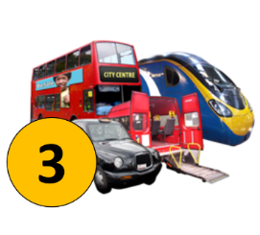 |  |  | Yes  ☐ |  |  |  |  | No  ☐ | Don’t know  ☐
 |  |  | Please write any comments here:
A cleaner and greener Kent  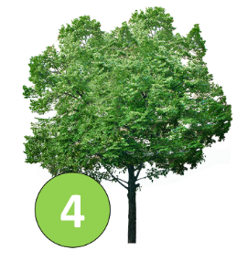 |  |  | Yes  ☐ |  |  |  |  | No  ☐ | Don’t know  ☐
 |  |  | Please write any comments here:
Stronger and safer Kent communities  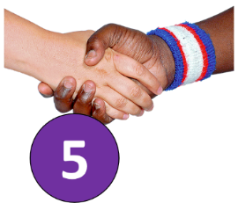 |  |  | Yes  ☐ |  |  |  |  | No  ☐ | Don’t know  ☐
 |  |  | Please write any comments here:
Opportunities for children and young people  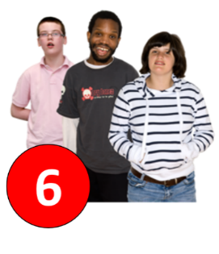 |  |  | Yes  ☐ |  |  |  |  | No  ☐ | Don’t know  ☐
 |  |  | Please write any comments here:
Quality health, care and support  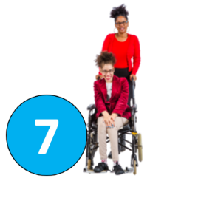 |  |  | Yes  ☐ |  |  |  |  | No  ☐ | Don’t know  ☐
 |  |  | Please write any comments here:
6. Equality Impact Assessment

We have completed an Equality Impact Assessment on the draft 5 year plan. This means we have looked carefully to see if anyone will be unfairly disadvantaged. You can view it on the internet at www.kent.gov.uk/5yearplan.

Our draft 5 year plan is a positive vision for what we want to do to improve people’s lives in Kent. We do not think it will have any bad impacts.

You can tell us what you think here:

7. General comments

Is there anything else you would like to say about our 5 year plan?

Please tell us in this box.

More about you
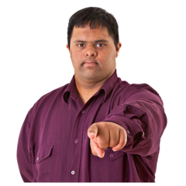 | These questions are about you  You do not have to fill them in if you do not want to.  We want to make sure everyone is treated fairly and equally, and that no one is left out.  That is why we are asking you these extra questions.
 | We will only use this information for this consultation and only use it to make our services better.
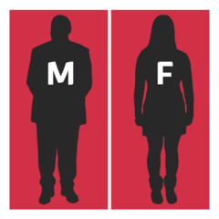 | 8. Are you? Tick one box only
 | ☐ |  |  |  | Male
 | ☐ |  |  |  | Female
 | ☐ |  |  |  | I prefer not to say
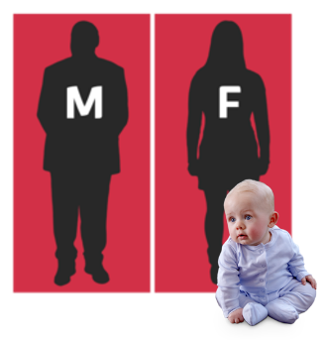 | 9. Is your gender the same now as when you were born? Tick one box only
 | ☐ |  |  |  | Yes
 | ☐ |  |  |  | No
 | ☐ |  |  |  | I prefer not to say
 | 10. How old are you?
 | ☐ |  |  |  | I prefer not to say
11. Do you have a religion or belief?
Tick one box only
 | ☐ |  |  |  | Yes
 | ☐ |  |  |  | No
 | ☐ |  |  |  | Prefer not to answer
 | 11 (a) If the answer is yes to the question above, which religion or belief is it? Tick one box only
 | ☐ |  |  |  |  |  | Christian
 | ☐ |  |  |  |  |  | Buddhist
 | ☐ |  |  |  |  |  | Hindu
 | ☐ |  |  |  |  |  | Jewish
 | ☐ |  |  |  |  |  | Muslim
 | ☐ |  |  |  |  |  | Sikh
 | ☐ |  |  |  |  |  | I prefer not to say
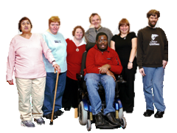 | 12. Do you have a disability? A disability is if you have a problem or an illness to do with your mind or body that makes it difficult to do everyday things. Tick one box only
 | ☐ |  |  |  | Yes
 | ☐ |  |  |  | No
 | ☐ |  |  |  | Prefer not to answer
 | 12 (a) If you answered yes to the question above, please tell us the disability or impairment you have. You can tick more than one box.
 | ☐ |  |  |  | Learning disability
 | ☐ |  |  |  | Physical impairment
 | ☐ |  |  |  | Sensory impairment (hearing, sight or both)
 | ☐ |  |  |  | Long standing illness or health condition
 | ☐ |  |  |  | Mental health condition
 | ☐ |  |  |  | I prefer not to say
 | ☐ |  |  |  | Other, please tell us what it is
 | ☐ |  |  |  | Learning disability
13. Are you a Carer?
A Carer is anyone who cares unpaid for a friend or family member who, due to illness, disability, mental health problem or addiction, cannot cope without their support. Tick one box only.

 | ☐ |  |  |  | Yes
 | ☐ |  |  |  | No
 | ☐ |  |  |  | Prefer not to say
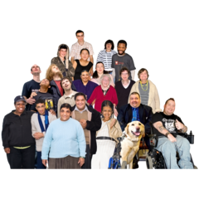 | 14. How would you describe yourself?
 | ☐ |  |  |  | White English
 | ☐ |  |  |  | White Scottish
 | ☐ |  |  |  | White Welsh
 | ☐ |  |  |  | White Northern Irish
 | ☐ |  |  |  | White Irish
 | ☐ |  |  |  | White Gypsy/Roma
 | ☐ |  |  |  | White Irish traveller
 | ☐ |  |  |  | White other*
 | ☐ |  |  |  | Asian or Asian British Indian
 | ☐ |  |  |  | Asian or Asian British Pakistani
 | ☐ |  |  |  | Asian or Asian British Bangladeshi
 | ☐ |  |  |  | Asian or Asian British other*
 | ☐ |  |  |  | Mixed White and Black Caribbean
 | ☐ |  |  |  | Mixed White and Black African
 | ☐ |  |  |  | Mixed White and Asian
 | ☐ |  |  |  | Mixed other*
 | ☐ |  |  |  | Black or Black British Caribbean
 | ☐ |  |  |  | Black or Black British African
 | ☐ |  |  |  | Black or Black British other*
 | ☐ |  |  |  | Arab
 | ☐ |  |  |  | Chinese
 | ☐ |  |  |  | I prefer not to say
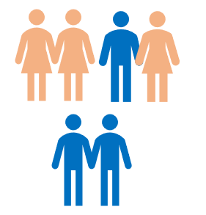 | 15. Are you? Tick one box only.
 | ☐ |  |  |  | Heterosexual/Straight
 | ☐ |  |  |  | Bi/Bisexual
 | ☐ |  |  |  | Gay women/Lesbian
 | ☐ |  |  |  | Gay man
 | ☐ |  |  |  | Other
 | ☐ |  |  |  | I prefer not to say
 |  |  |  |  | Thank you for taking the time to give us your views.
How we use your information

Information you give to us is used in line with the General Data Protection Regulation.

This is a law which tells us how we should treat personal information.

We ask for information about you to check everyone is treated fairly and no one gets left out.

Kent County Council will share your details with services within the Council who are responsible for this consultation.

Any information given will not be used to identify you.

Information will be held securely stored for 6 years.

