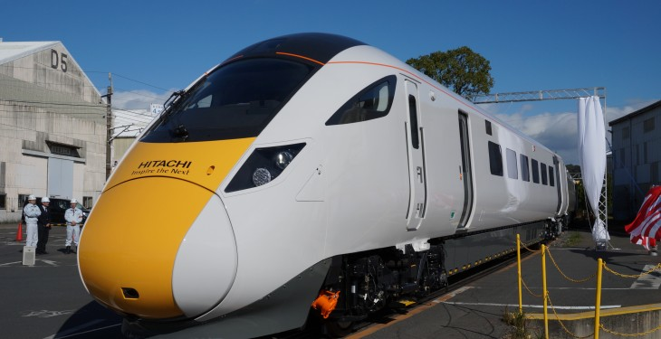

Kent County Council
Response to the
South Eastern Rail Franchise Public Consultation

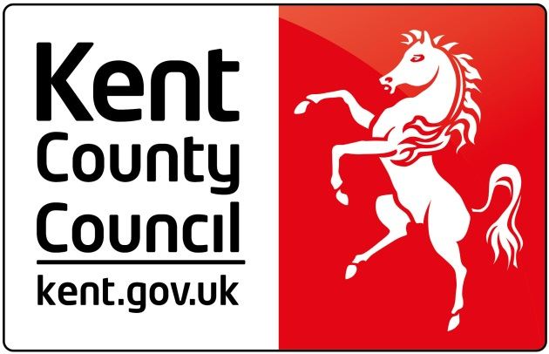
County Hall
Maidstone
May 2017
ACKNOWLEDGEMENTS
Frontispiece
Class 800 Hitachi High Speed train on delivery from Newton Aycliffe plant, County Durham – a type of High Speed train required for the new South Eastern franchise

Growth and Infrastructure Framework, Kent County Council and Medway Council, 2015
Extracts from document demonstrating projected growth in housing and employment in Kent and Medway to 2031

Local Transport Plan 4: Delivering Growth without Gridlock
Extract from final draft of LTP4, Transport Strategy Team, Kent County Council

Map of Kent Rail Network
John Luckcock

Picture in response to question 3 (Metro services)
Class 707 Siemens Metro train on delivery for the South West Trains franchise – a type of Metro train required for the new South Eastern franchise

PowerPoint slides
From presentation made by Kent County Council to Chartered Institute of Logistics and Transport – Kent Group, November 2016

Rail Action Plan for Kent
Extracts from document published by Kent County Council, April 2011

Thanet Parkway – Artist’s Impression
Extract from Kent County Council’s public consultation on new parkway station

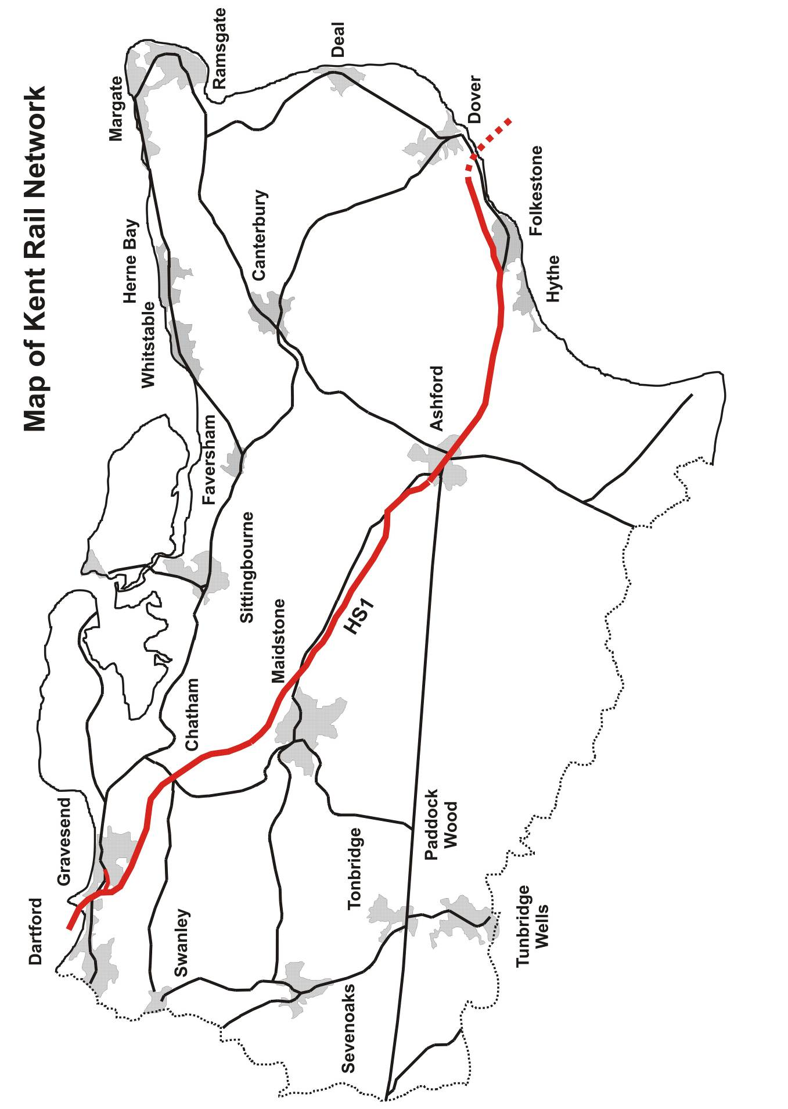

FOREWORD

Kent County Council (KCC) welcomes the opportunity to respond to the Department for Transport’s (DfT) public consultation on the new South Eastern Rail Franchise (SERF). The Council published its ‘Rail Action Plan for Kent’ in April 2011, setting out KCC’s rail policy with a view to informing the next franchise specification.

This was how the Council introduced its Rail Action Plan for Kent:

“We live in exciting and challenging times. We need to ensure that the right conditions are in place for the economic regeneration and growth that we all want to see in Kent. Only from economic growth can we provide for our children’s future and create the opportunities for business, education, employment and leisure that are so crucial to the life of the County of Kent and its people.

The rail service in Kent is a key driver of these noble objectives. A modern, efficient, safe, punctual and reliable rail service that takes people where they need to go at a time of day that meets their needs is central to the transport objectives of Kent County Council. Only by ensuring the provision of good rail links to the right London termini, and between stations within Kent, can we enjoy a rail service that not only meets the needs of today’s travellers, but that is able to respond to the ever increasing pressures of tomorrow’s passengers too.”

[Source: Foreword, Rail Action Plan for Kent, KCC, April 2011]

The same principles still apply today, and in this response to the DfT KCC prioritises the need for enhancements in capacity, reliability, frequency and customer service which residents and businesses of, and visitors to, Kent deserve to see delivered in the new franchise.

Paul Carter CBE
Leader
Kent County Council

May 2017

Section A

1. About you

We would like to know more about your interest in South Eastern railway. We are asking for this information to enable us to identify whether there are themes in the comments and questions raised by different customer and stakeholder groups.

This response is made on behalf of Kent County Council.

2.1 We would also be grateful if you would provide some information on what kind of organisation you work in or volunteer for, as is most relevant to your interest in the South Eastern franchise. Please pick one of the following answers:

Local authority

2.2 Please provide a summary description of your organisation.

Local Transport Authority (LTA) covering the administrative area of the County of Kent. Established in 1889 and now having 81 elected County Councillors.

2.3 If we want to explore your comments in greater detail, we may like to contact you so please provide your name and the easiest contact details for you. This is entirely optional – you do not need to provide this information if you do not wish to do so. Any contact information you do provide here will be kept confidential and will not be published. Please see page 3 of the consultation document on how your information will be handled.

Name: Stephen Gasche

Title: Principal Transport Planner - Rail

Telephone: 03000 413490

Email: stephen.gasche@kent.gov.uk

2.4 If you are happy for us to know it, please tell us the name of your organisation - this is entirely optional. Please also put an X in the box if you are happy for us to list your organisation in the published outcomes report as a contributor to the consultation. Please see page 3 of the consultation document on how your information will be handled.

Organisation name: Kent County Council

Can we include your organisation in a list of contributing organisations:

Yes, we agree to our organisation being listed in the published outcomes report as a contributor to the consultation.

2.5 How are the views of your members assembled?

The views of our members, and those of other partners and stakeholders in Kent, have been assembled through their responses to our activities in assembling views on the key issues to be included in the new franchise specification. Our own consultations to inform this KCC response have included engagement with the following:

KCC Leader and Cabinet Members
KCC Members of the Environment & Transport Cabinet Committee
Kent & Medway Economic Partnership
District and Borough Councils
Sevenoaks Rail Travellers Association
Tonbridge Line Commuters
Kent Community Rail Partnership
North Kent Rail Users Group
Network Rail’s draft Kent Route Study.
Consultation responses from KCC sponsored projects (e.g. Thanet Parkway station)

Section B

- Do our priorities reflect your views?

Yes. The key issues required by KCC align with the priorities addressed in the DfT consultation for the new SERF, namely:
- The provision of sufficient capacity (on both the High Speed and Mainline services)
- A reduction in journey times
- Delivering higher quality and additional rolling stock (on both the High Speed and mainline services)
- Improving punctuality / reliability of service provision and response to disruption
- Improving connectivity to destinations within and beyond the county
- Improving the stations
- Willingness to work in partnership with stakeholders
- Commitment to Smart Ticketing
- Roll out of unified communications to passengers
- Enhancements to car parking capacity at the busiest stations
- Offering options relating to the provision of first-class accommodation
- A commitment to support and engage in Community Rail Partnerships
- Examination of regulated fare levels on all Kent’s rail services

The Secretary of State for Transport has also extended a specific invitation to KCC to be involved in the determination of the new franchise specification. KCC has already taken up this offer to ensure that the interests of Kent’s rail passengers are represented in the decision-making process led by the DfT.

As well as the rail policy established in KCC’s ‘Rail Action Plan for Kent’ referenced in the foreword to this response, the Council’s new Local Transport Plan (LTP4) following a full public consultation process is being finalised for approval in July 2017. The new LTP4 will set out the Council’s rail and transport priorities, and will acknowledge the significant opportunities presented by the new franchise consultation.

- Do you agree that more space is needed for passengers at the busiest times of the day?

Yes. The Kent and Medway Growth and Infrastructure Framework (GIF) sets out the planned growth in population, housing and employment across the county to 2031 and the infrastructure required to support that growth. This predicts a substantial increase in demand for rail passenger services between Kent and London for access to employment, education and leisure purposes. The proposals for enhancements to the rail service in Kent in this response reflect this planned increase in population and demand for rail transport, which will be one of the key drivers of enhanced passenger rail services in the new SERF. The tables below set out the projected growth in housing and employment in Kent and Medway to 2031.

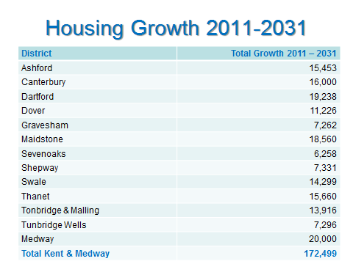

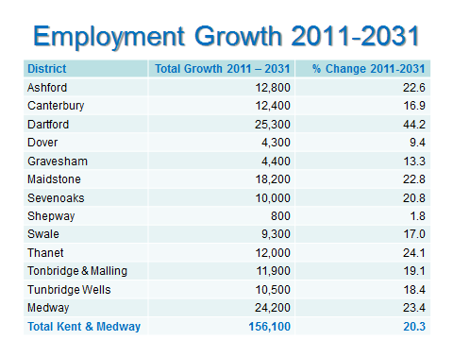

[Source: Strategic Business Development & Intelligence, Kent County Council]

- What do you think of the options for providing more space on trains?

KCC supports a number of options for providing more space on trains. In some instances, this can be achieved by lengthening existing services (e.g. in peak periods where trains currently operate below the maximum operating length), while in other instances this can be delivered through an enhancement in the level of frequency (e.g. in off-peak periods). These options can be summarised for each sector of the new SERF as follows:

High Speed Rolling-Stock

There will be a need for the DfT to require the successful franchise bidder to enter a lease agreement with one of the Rolling-Stock Companies (ROSCOS) to place an order for the following new Class 395 (or successor) High Speed units:

- 12 new 6-car sets for uplift to Ashford / Canterbury / Dover service
- 3 new 6-car sets for new Ashford / Rye / Hastings service
- 5 new 6-car sets for uplift to Ebbsfleet service*

* this requirement reflects the need for a dedicated service to provide the additional capacity required for the planned housing development at Ebbsfleet Garden City and the proposed leisure park on the Swanscombe peninsula

Total: 20 new 6-car sets (includes operational spares)

Mainline Rolling-Stock

There is a DfT plan to cascade stock from Thameslink from 2017 onwards, whereby the new Class 700 stock on that franchise will release a number of
4-car Class 377 Electrostars to Southeastern. These should in turn release some of the Class 465/466 stock, which would transfer to the Metro network to strengthen existing workings and thus deliver additional capacity there.

KCC supports this cascade plan, as it will enable the removal of many of the Networker trains from Kent where they are not fit for purpose. The Mainline Kent network requires Mainline trains with appropriate facilities for mid to long distance journeys, and the DfT cascade proposal should deliver this enhancement by the time the new franchise commences.

Beyond 2018, the following enhancements will be required in the new franchise:

- Class 375 stock refurbishment to be completed, with partial transfer of some First Class to Standard Class seating included
- Class 377 stock to be refurbished and re-liveried
- Class 465/466 stock to be partly removed to Metro services, and replaced with transferred stock as above.

The Mainline Kent network should then be served as follows:

- Class 375: London - Chatham – Ramsgate / Dover
- Class 375: London – Tonbridge – Ashford – Ramsgate / Ramsgate
- Class 375/377: London – Maidstone East – Ashford – Canterbury West
- Class 375: London – Tonbridge – Tunbridge Wells - Hastings
- Class 465: London – Tonbridge – Tunbridge Wells

The two Community Rail Partnership (CRP) lines should be served as follows:

- Class 375/3: Strood – Maidstone West – Tonbridge
- Class 375/3: Sittingbourne – Sheerness-on-sea

Metro Rolling-Stock

There needs to be a bold initiative for the new franchise. The renewal of the oldest part of the Metro fleet (Class 465 & 466) should be a requirement in the new franchise specification. A competition between the ROSCOS should therefore be a requirement for the successful franchise bidder, with a commitment to the renewal of the Metro fleet with increased capacity. The rolling-stock newly introduced on the South West Trains franchise (Class 707) is an exemplar of the type of train required by busy commuter Metro services, and would deliver the additional capacity required on the Metro services operating in Kent to and from Dartford, Gravesend and Sevenoaks.

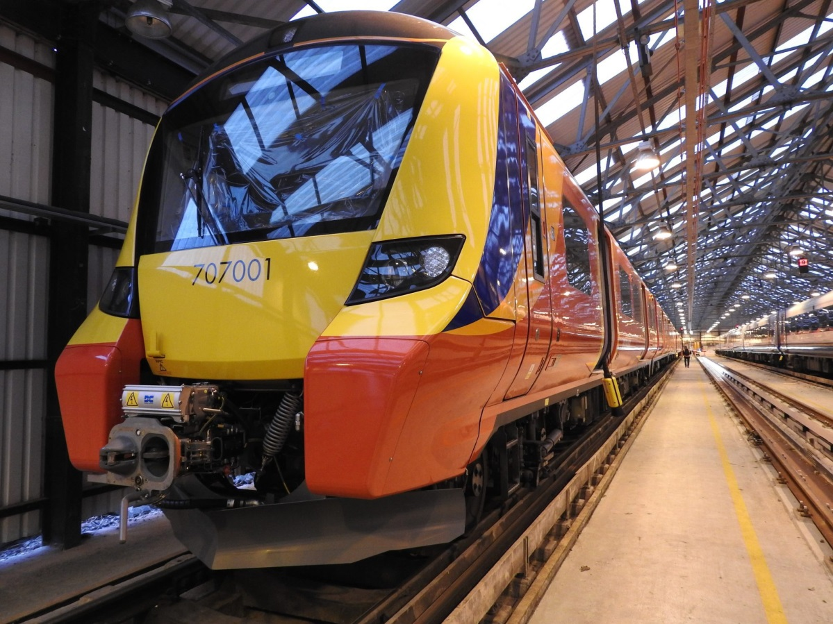

Class 707 Siemens train ready for delivery to South West Trains
- Would you support removing First Class seating on the busiest routes to provide more space?

Yes, to some extent. There is still a demand for First Class travel, although this is only significant in the peak periods on Mainline services and virtually disappears at other times. The current refurbishment programme which is upgrading the Electrostar Class 375 trains includes a reduction from 24 to 16 First Class seats in each 4-car unit. This seems a reasonable and proportionate response to changing patterns of demand for First Class accommodation, providing additional Standard Class seating while retaining a First Class facility for those passengers wishing to pay the additional fare to secure a seat in peak periods.

- What comments, if any, do you have on our plans to improve customer service and the overall passenger experience?

KCC regards the overall passenger experience as an essential element of any rail journey. Too often in the past there has been insufficient attention paid to the many smaller issues which together give the passenger an overall impression of the rail service provider. While some elements of customer service are clearly more essential than others, it is the overall passenger experience which should provide the benchmark against which the success – or otherwise – of the franchise operation should be judged.

KCC’s principal requirements for improved customer service therefore include the following elements:

Improved punctuality / reliability of service provision and response to disruption

While there have been some improvements in performance by the existing operator, there is one element still in need of improvement: this is the ability to respond to, and recover from, disruption. Service disruption can be caused by a range of incidents, many of which are outside the control of the operator. The new SERF award must require the chosen operator to establish robust procedures to restore the service as quickly as possible with the support and regular communication of accurate passenger information.

Improved connectivity to destinations within and beyond the county

The requirements for service enhancements in the new franchise have been set out earlier. There is also a need for improved connectivity, both within and beyond the county, at these specific stations:

- Strood, for passengers between Maidstone West and Medway Towns
- Tonbridge, for passengers between Maidstone West and Redhill / Gatwick
- Otford, for passengers between Sevenoaks and Maidstone East
- Dover Priory, for passengers between Sandwich / Deal and Canterbury East

Improvements to Stations
In general stations and their environments should be recognised as gateways to the towns, villages and environments they serve. Stations should be clean, tidy and efficient, and as far as is practicable those close to major employment areas should reflect their business location.

Furthermore, rail travel should be integrated with other sustainable modes, such as bus, river, walking and cycling. There should be appropriate interchange infrastructure improvements and through ticketing initiatives with other service providers. The development of station travel plans with stakeholders should be encouraged for principal stations. There is also now an expectation that wi-fi facilities will be provided on all train services to enable business activity while commuting.

Additional aspirations for all stations should be to include, where not already in existence:

- Car Parking: there is significant increased demand for additional car parking capacity at a number of stations across the SERF area. Some of this demand is current; some will be driven by the planned delivery of the new Thameslink service on the Maidstone East line.

At the very least, the following stations will need to be assessed for decking of their existing car parks, but there will be other candidates as levels of demand adjust beyond the start of the new SERF:

Ashford International – car park B
Canterbury West – jointly with Canterbury City Council
Maidstone East
Otford
Tonbridge
West Malling

- Cycle parking: improved quantity and security of cycle parking at all stations, and where it exists already, upgrades to covered provision.

- Heritage: it is appropriate for stations in historic locations to reflect their local heritage. This can take the form of suitable advertising and signing on station sites, to direct links between a station and a local tourist attraction (e.g. Bearsted and its bus link to Leeds Castle).

- Signposting: station signs should be clear and unambiguous, from station name-plates to signing between the station and the local town or village centre.

- Ticket machines: ticket vending machines offering the full range of tickets available from each station, with the same range of fares as are available from the ticket office.

- Toilets: station toilet facilities should be clean, regularly inspected, well lit and, critically, open for the duration of passenger services.

- Waiting facilities: every station should have a place to wait that is comfortable, warm and safe. Waiting facilities should be well lit, with good all-round visibility to assure travellers that they are safe.

- Do you have any other ideas or priorities for improving customer service?

Other proposals are contained in the responses to following questions.

- What changes to the fares structure would be of benefit to you?

Regulated Fares

The SERF should be a catalyst for a step-change in the Government’s directed fares policy. At present, regulated fares rise by RPI + 0% in January each year, as determined by the measurement of RPI the previous July. As the increase in almost every other cost or benefit is determined by the generally slightly lower CPI, this should become the new measure of annual regulated fares, i.e. CPI + 0%. This would at least address some of the concerns of rail passengers at the very high annual percentage increases with which they are hit every New Year, determined almost by chance by the previous July’s measure of inflation.

There needs to be a new deal between the Government and the rail passenger, which, while recognising the need to move from tax-payer subsidy to rail-passenger revenue, nevertheless eases that transition by adopting this new measure of regulated fares.

The High Speed services operating in Kent charge a further premium fare, representing 30% in addition to the ordinary fare (whether season, anytime day
return or off-peak return) for that portion of the journey on High Speed 1. This represents a substantial additional cost, especially for peak-time commuters, and the level of additional premium needs to be reduced as part of the financial agreement between the DfT and the operator for the new franchise.

Unregulated Fares

The off-peak fares available in Kent, which are all unregulated and so determined solely by the franchise operator, usually offer very good value for money, especially when purchased with one of the wide range of rail cards available. The new SERF should expand the current offer, promoting ‘super off-peak’ fares on weekdays and all day at weekends and public holidays, to encourage greater use of spare capacity on off-peak trains between Kent stations and London and also within Kent to tourist attractions such as Canterbury and Margate.

- What else could be done to improve the way tickets are sold and provided?

The new SERF should develop Smart and Mobile forms of ticketing with a ‘best price’ promise across all ticket media.

The new franchise operator should be required to continue the development of the Smart Ticketing initiative developed by the current operator, and to extend it to cover individual as well as season tickets.

This Smartcard scheme should also incorporate an option for flexible ticketing, whereby commuters can choose to travel on fewer days of the week, reflecting modern office / home working practices.

The new franchise operator should also commit to a collaborative approach with KCC, so that when technology enables it, a new ‘Kent Smartcard’ scheme would be delivered to incorporate travel by bus and rail services across the county.

The Sevenoaks Rail Travellers Association (SRTA) has provided an informed and well developed strategy on a wide range of issues affecting Sevenoaks. Their specific proposal concerning ticketing is supported by KCC:

“SRTA would like to see Zonal fares extended to Dunton Green and equivalent north Kent stations. We would support Sevenoaks being treated in a manner similar to Watford Junction in having a special fare (set by the railway TOC, not TfL) but integrated with London Zonal fares.

Consideration should be given to including the Darent Valley line stations if both Swanley and Sevenoaks were in the Zonal system.
The SRTA do not have a view on the technology employed, provided it is not less than the facilities of the current Oyster card and usable by commuters for all tickets on all TfL services. “

[Source: Sevenoaks Rail Travellers Association (SRTA): Preliminary Thoughts for the Kent Franchise, December 2015]
- What further comments, if any, do you have on our plans to improve access and facilities at stations?
The new SERF operator should be required to develop the existing joint working arrangements with Network Rail (South East route) to ensure unified and timely communications to passengers. The provision of smart phones for station staff needs to be supported by a unified approach to the provision of regular, informative on-screen train displays and PA announcements.

This approach is especially important in responding to disruption in service, when a unified approach with clear and accurate information becomes an even greater need for the travelling public.
- What more could be done to improve access and provide facilities for those with disabilities or additional needs?

Access for All

While good progress has been made at many stations in Kent, there are many which still do not offer level access to all platforms. It is a sign of a civilised society that those with the greatest disabilities should be afforded the greatest facilities, especially to enable a joined-up and step-free rail journey. The new SERF specification should include a requirement for the new operator to commit to further significant investment in Access for All facilities at stations, to work towards an entirely accessible rail network in Kent.

- How far do you support, or oppose, the extension of High Speed services from London St Pancras to Hastings, Bexhill and Rye, where this would represent value for money to the taxpayer?

KCC strongly supports the proposed extension of High Speed services to Hastings and Bexhill via Ashford and Rye. The principal reasons for this strong support are:

- To generate growth in East Kent and East Sussex (as part of a wider increase in High Speed service levels across the new SERF network)
- To deliver additional High Speed capacity to Ashford, as well as to Rye, Hastings and Bexhill in East Sussex
- To relieve capacity constraints on the Tonbridge – Hastings route
- To be supported by KCC’s submission for an additional fleet of High Speed bi-mode rolling–stock (see response to Q22)
There is a specific option for funders included in the proposed list of enhancements in the draft Kent Route Study recently published by Network Rail for Control Period 6 (CP6: 2019-2024) which could enable this new service to operate. This is for a realignment of the track layout at Ashford International station, to join the track serving the London end of platform 2 (which is accessible from the Marshlink route) to the Ashford Spurs which link through to High Speed 1.

The delivery of this project, provided funding were allocated in the settlement for the Kent Route for CP6, would facilitate the through operation of High Speed bi-mode services between London St Pancras and Hastings / Bexhill via Ashford and Rye (see proposed High Speed service table in response to Q15).

- How far do you support, or oppose, reducing journey times to key destinations in Kent and East Sussex, by reducing stops at less well used intermediate stations to create hourly fast services?

KCC supports this proposal in principle, dependent on the route concerned.
For example, it may be possible to reduce the journey time between some stations and London by operating both fast and slow services with suitable timetabled connections (e.g. Faversham on the North Kent line).

Any change in stopping patterns though must retain at least an hourly service at smaller stations, and must be delivered within the existing rolling-stock capacity.

- If you support this proposal, which services do you think would most benefit from this approach?

The service between Ramsgate and London via Chatham could be operated as a fast service, connecting at Faversham with a stopping service operating from Dover to London via Chatham. As Dover has both High Speed and Mainline services to other London termini, the service via Canterbury East and Faversham could provide an all-stations stopping service as far as Bromley South, and then to Victoria. This would facilitate a much faster service from Ramsgate, which after Faversham (with cross-platform connections) would call only at Sittingbourne, Gillingham, Chatham, Bromley South and Victoria.

The Ashford to London via Tonbridge service though would need to retain its current stopping pattern, to reflect the growth in demand at intermediate stations on this route. There is considerable housing development underway or planned at Paddock Wood, Marden, Staplehurst, Headcorn and Pluckley, which will require the continuation of the present service levels in both peak and off-peak periods. Therefore the new SERF specification should commit to these service levels, without any change in either the frequency or the stopping pattern on this section of route. As Ashford and most East Kent stations already have a High Speed service, there is in any event less imperative to speed up this Mainline route.

The Hastings to London via Tonbridge service, however, could be considered for alternating fast and slow services, as there is (at present) no High Speed alternative, although this pattern would need to be revised when High Speed services commence from Hastings. It would be essential to ensure that the smaller stations on this route were adequately served, with the operation of portion working in the peak periods whereby fast and slow portions joined / divided at Tunbridge Wells.

KCC’s proposals for service levels in the new SERF are summarised in the response to Q15.

- Which journeys do you take today which are difficult:

By rail?
By road, which would be easier by rail?

This question is not applicable, as this response is submitted on behalf of Kent County Council.

- Which additional services would you wish to see provided in the next franchise?

There are a number of additional services, and also some changes to the existing pattern of services, for which KCC would wish to see provision made in the new franchise. These are grouped into each of the three distinct categories of service identified in the consultation. Summaries of the proposed improvements to services in all three categories are shown in tables below, but full details of the proposed frequencies and stopping patterns are shown in Appendix A.

Metro

Following the transfer of the service from London Charing Cross via Blackheath and Woolwich Arsenal to Dartford, Gravesend and Gillingham / Rainham from the existing franchise to the Thameslink franchise in 2018, there will be two Metro routes serving Kent in the new SERF:

- London Charing Cross / Cannon Street via Woolwich or Sidcup to Dartford, Stone Crossing, Greenhithe, Swanscombe, Northfleet and Gravesend;

- London Charing Cross / Cannon Street via Grove Park and Orpington to Chelsfield. Knockholt, Dunton Green and Sevenoaks.

These Metro services provide an essential part of the rail network in Kent, providing access from Dartford, Gravesend and Sevenoaks to and from the capital. While the overall provision of rail capacity in north-west Kent would be significantly enhanced if the proposals for an extension of the Elizabeth Line (Crossrail) were implemented (see separate special note later in this response), the immediate need in the new SERF is for a new rolling-stock fleet to improve the quality and reliability of these Metro services in Kent.

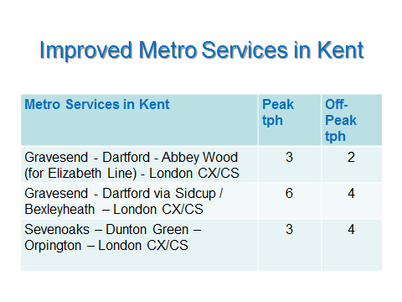

Mainline

The need for growth in Mainline rail provision has been identified at these principal locations:

  - Faversham
  - Sittingbourne
  - Maidstone East
  - West Malling
  - Borough Green & Wrotham
  - Otford
  - Tunbridge Wells*
  - Tonbridge*
  - Sevenoaks*

* There should be significant easement at these stations when the new Thameslink service from Maidstone East to the Thameslink core stations commences in 2018

The list of stations where capacity improvements are required excludes those located within the Medway Council area, which will be addressed by Medway Council’s submission to the DfT for the new franchise.

Any overall increase in the provision of Mainline services will be dependent on two key factors:

- The provision of sufficient paths to the London termini
- The provision of additional Mainline rolling-stock for peak period operation

At present, the peak paths to and from London termini are full (with the exception of some limited spare capacity on the route from Lewisham to Victoria via Nunhead). In practice, therefore, the greatest opportunity for any Mainline service enhancement in the new franchise will be in the strengthening of existing services in the off-peak and weekend periods.

There is significant overcrowding on “shoulder-peak” services on Mainline routes, and also on late evening departures from London. These issues will need to be addressed by the new franchise operator to ensure the delivery of a better Mainline service at these times for rail passengers.

As a minimum standard, all peak and shoulder-peak workings should be diagrammed as 11-cars or 12-cars. The planned cascade of Class 377 Electrostars from Thameslink to the current franchise will provide a much needed increase in suitable Mainline rolling-stock, replacing the Networker stock which will then be further cascaded to the Metro network to strengthen these services.
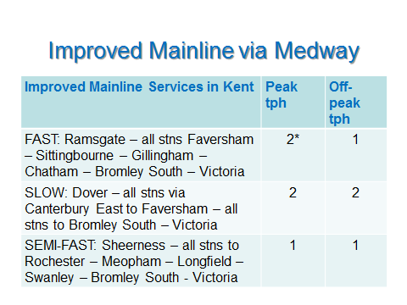

* The full peak service is not shown here, as this also includes the Ramsgate via Medway fast services to/from Cannon Street
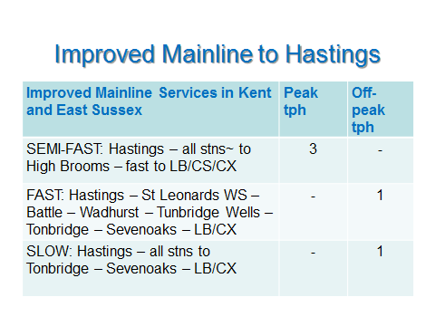
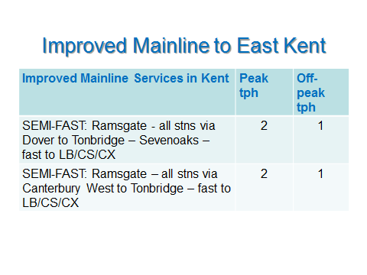
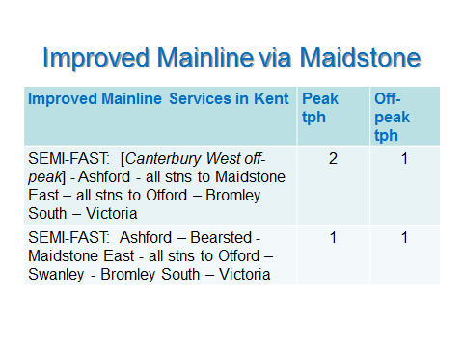
High Speed

The need for growth in High-Speed rail provision has been identified at these principal stations in Kent:

- Thanet Parkway (due to open in 2020)
- Canterbury West
- Dover Priory
- Folkestone Central
- Folkestone West
- Westenhanger (to serve proposed Otterpool Garden Town)
- Ashford International
- Ebbsfleet International
- Maidstone West

There is clearly demand, both existing and projected (see GIF statistics in response to Q2), for a significant increase in High Speed capacity. In the peak periods this will need to be provided through 12-car operation of all peak services with an expanded High Speed rolling-stock fleet (see response to Q22). In the off-peak periods this will need to be met by a doubling of service levels on the East Kent routes via Ashford. Summary details are given in the tables below.

Special note on Thanet Parkway

The new Thanet Parkway station is due to open in 2020, providing a reduced journey time from Thanet to London which will be delivered in partnership with Network Rail through completion of the Journey Time Improvement (JTI) scheme between Ramsgate and Ashford. The new SERF specification will need to include a requirement for all trains which pass the new station to stop there, both Mainline and High Speed services.

Timetable analysis undertaken by Network Rail has demonstrated that there would be no additional costs involved in terms of rolling-stock or crews, but that the round-the-loop High Speed service would need to have an adjustment to its stopping pattern to accommodate the additional station stop. With the proposal above to extend the Mainline service from Dover to Ramsgate via Sandwich all day, this will facilitate the removal of Martin Mill from the High Speed service and its replacement with Thanet Parkway.

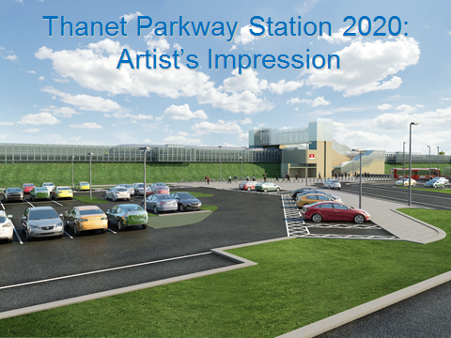

Special Note on Westenhanger

The proposed Otterpool Garden Town development adjacent to Westenhanger station will generate a significant increase in demand for rail services, principally to/from London. Once the expanded station is completed (and this will need to be entirely privately funded by the developers) the new SERF specification will need to accommodate stops on the High Speed service. There are two principal ways of delivering this additional stop:

- an alternative stopping pattern between Westenhanger and Folkestone West, which, while retaining the existing 1tph off-peak service at the latter station as this route is proposed to be increased to 2tph off-peak, would have the disbenefit of introducing alternate stopping patterns for passengers travelling from London;

- an additional stop on all High Speed services which, while serving Westenhanger regularly, would have the disbenefit of extending the running time to/from all the existing Folkestone and Dover stations.

Both options should be included in the SERF specification for consultation with local stakeholders when the station development is completed at some point during the period of the new franchise.

Special Note on Proposed Leisure Park at Swanscombe Peninsula

Planning consent is currently being sought for a new leisure park on the Swanscombe Peninsula. If this is developed as currently planned there will be a substantial increase in demand for High Speed rail services between Ebbsfleet and London, Ashford and Medway. KCC has therefore included a proposal in its submission for a significant increase in High Speed provision at Ebbsfleet, to accommodate planned demand from Ebbsfleet Garden City and projected demand for the new leisure park. The level of High Speed service provision will need to keep pace as these developments are progressed during the course of the new franchise.

Special Note on High Speed Services to East Sussex

As recognised above in response to Q11, there is also a specific funding option in the Kent Route Study for the inclusion of enhancements to the Marshlink route to enable the operation of High Speed services on this route using new hybrid-powered High Speed rolling stock. On that basis the following stations in East Sussex are also included here for the purposes of proposing a new service pattern for the High Speed network:

- Rye
- Hastings
- Bexhill

Special Note on Sandwich Open Golf Tournament

An additional temporary service will also be required to serve the Open Golf tournament at Sandwich in 2020. It is proposed that this event will be served by a dedicated High Speed operation to/from London St Pancras, which will need to be included as a franchise requirement. There is a planned temporary extension of both platforms at Sandwich to facilitate 12-car High Speed operation for the duration of this event from 12-19 July 2020.

Special Note on Tourism and Leisure Travel in Kent

During the past 15 years, the visitor economy in Kent has doubled in size. The county attracts over 60 million visitors per annum, placing it in the top 10 most successful domestic destinations in England and the third most successful destination for international visitors outside London, attracting more than 1 million international visitors each year. The strong collaboration, facilitated by Visit Kent, between the tourism businesses and the transport operators in Kent, is one of the contributing factors to this success, with a host of joined up tactical activities and campaigns driving new demand, particularly in the off peak periods.

Good examples of this activity coordinated by Visit Kent, and in turn promoted and in some cases co-financed, are 2 for 1 offers at attractions, tactical pricing campaigns, poster campaigns at London termini, on platforms and trains and tactical sign posting and mapping at stations. This work needs to be continued in the new South Eastern franchise, and further built upon to ensure that the potential of the visitor economy, particularly in driving demand for off peak services, is maintained and grown.

The image and economy of the Kent Coast has been transformed thanks to the availability of High Speed services and cultural assets such as Whitstable Biennale, Folkestone Triennial and Turner Contemporary; in addition, of course, the world wide appeal of the City of Canterbury continues to act as a major attraction. In fact, there has been a surge of visitors enjoying the coast by train from London over the last 5 years on which there is potential to further capitalise

There is potential for much greater collaboration between the destination and the rail operator including engaging the private and public sector in supporting the place-making agenda around stations to support the “last mile” issue, aggregating rail fare destination offers, such as deals for hotels, attractions at hotels., staffing with volunteer greeters, location maps, orientation and providing better all-round welcome to arriving visitors.

Further, there are initiatives that Visit Kent and other partners across the County are exploring with respect to maximising the opportunity for young people and families to access travel by rail, with which we would expect the new franchisee to engage.

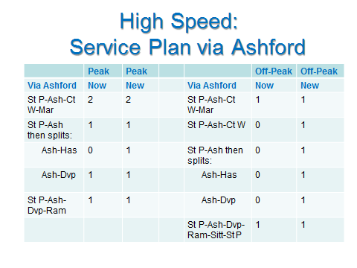
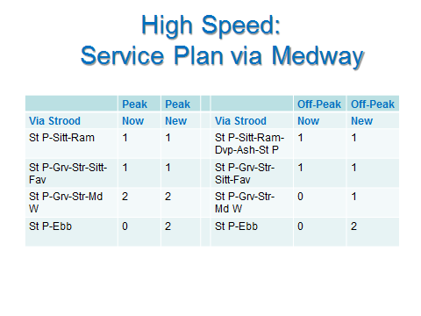
- How far do you support, or oppose, options to simplify the timetable?

KCC supports options for simplification of the Metro timetable. For example, the three routes between London and Dartford, while operating mainly to a clockface timetable today, could perhaps be simplified in terms of operational patterns. With the transfer of the London to Gillingham / Rainham service to Thameslink, the Metro service pattern on the new SERF will be simpler than the present pattern of service anyway. One of the key objectives should be to enhance access to/from Abbey Wood for a change to/from the Elizabeth Line service from December 2018.

The Metro service to/from Sevenoaks cannot be increased from its present 3tph in the peaks due to capacity constraints, but KCC does support the proposal from the Sevenoaks Rail Travellers Association for a 4tph service in the off-peaks. This could be achieved by extending the existing 2tph Cannon Street–Orpington service to/from Sevenoaks. A clockface 4tph off-peak service should then be provided.

- How far do you support, or oppose, options to reduce the choice of central London destinations served from individual stations with the aim of providing a more regular, evenly spaced timetable, and a more reliable service?

KCC supports the option for some of the Dartford Metro services to have a single London terminal. For example, there would be an operational logic if the Bexleyheath line services joined the North Kent via Greenwich services in using Cannon Street as their terminus, with all Gravesend / Dartford via Sidcup services using Charing Cross. This would deliver the benefit of reduced conflicts at Lewisham junction, especially in the peak periods, and thus add to the overall reliability of the network.

KCC strongly opposes the use of a single London terminal for the Mainline services from Kent. The total of these is fewer in number than on the Metro network, and there remains a distinct demand for Cannon Street services from Kent (and East Sussex) especially in the peak periods

- How far do you support, or oppose, plans for the train operator and Network Rail to form a close alliance with the aim of reducing delays and improving performance?

KCC strongly supports plans for the train operator and Network Rail to form a close alliance with the aim of reducing delays and improving performance. This needs to be much deeper and broader than the current Southeastern / Network Rail joint Kent Integrated Control Centre (KICC), with a joint management team and joint operational responsibilities, supported by a robust response policy when there are delays to ensure the restoration of the timetable. The successful example of the former alliance between South West Trains and Network Rail’s Wessex Route is one that KCC would expect to see emulated in the new SERF.

- What are your views on how this alliance should be incentivised and held to account for its performance?

The success of the new alliance should be rewarded or penalised through revenue support / payments based on objective performance criteria, e.g. delivery of improved PPM scores. The new SERF specification should require both the franchise operator and Network Rail to be jointly accountable.

- How would you prefer the next South Eastern operator to engage with you?

- As an individual? - Not applicable.
- As an organisation? - Yes.

There are several ways in which KCC would expect the new SERF operator to engage with us as the largest public stakeholder in the franchise operating area:

- By developing the existing joint liaison which has been developed over the past 11 years between KCC and the TOC, to ensure that KCC’s expectations of the new SERF are delivered by the franchise operator
- By committing to attend and participate in the annual KCC Rail Summit
- By developing the existing TOC stakeholder events
- By responding to specific requests for timetable changes and other service improvements when these are justified by increased or changed demand
- By committing to serve the new Thanet Parkway station, when completed, with all High Speed and Mainline trains which pass.

- What approaches to customer service in other companies could be adopted by the next South Eastern train operator?

There are a number of areas in which the adoption of practices used in other TOCs could beneficially be deployed by the next SERF operator:

- Expansion of ‘The Key’ Smartcard to embrace flexible working days for season ticket holders, as well as standard peak and off-peak tickets

- Improve ‘customer respect’ which is usual in other TOCs. While there has been a significant improvement in recent years in the present franchise, a minority of staff still use an old British Rail approach to customers with colloquial terms of address - all customers should be addressed as ‘Sir’ or ‘Madam’ at all times

- Unified communication between staff, electronic display units and the KICC, so that at times of disruption everyone receives the same message at the same time

- Establish a norm of staff being present on platforms, not in the staff mess room

- Training of all ticket office staff to reflect best practice in other TOCs, so that the passenger experience purchasing a ticket at, for example, Maidstone East would be as good as it is at Ashford International

- Where do you think private sector investment would be of most benefit to the railway?

Private sector investment can most beneficially be utilised for the leasing of new rolling-stock from one of the ROSCOS as required for each sector within the new SERF.

Metro

The new Class 707 rolling-stock being delivered to the South West Trains franchise is a good example of the Metro-style fleet required. These trains provide additional standing capacity for passengers making short journeys, with a design that also maximises the amount of seating within the available space.

Mainline

The Mainline services will benefit from the proposed cascade plan within the present franchise operation, whereby the new Class 700 stock delivered to the Thameslink franchise will release a further number of 4-car Class 377 Electrostars. These should be included in the existing refurbishment programme of the Electrostar fleet currently being undertaken by Bombardier.

High Speed

As described earlier, there is demand for an increase in the size of the High Speed fleet, with private funding required for the leasing of new High Speed stock from one of the ROSCOS. This will need to be the highest priority for the successful SERF bidder, with a leasing agreement signed at the earliest opportunity.

- Should we consider using the more lightly used sections of the railway in a different way? If so, how should this be done?

Yes. KCC has been committed to the Community Rail Partnerships (CRP) for several years, and supports both the Kent and Sussex CRPs. Both CRPs promote and support the more lightly used routes in Kent, and also across the border into East Sussex and Surrey.

The new SERF operator should be required to commit to financial support for, and engagement with, the Kent Community Rail Partnership (CRP). This CRP has been successfully supported by the existing franchise operator, and this work should continue.

There are currently two routes in Kent supported by the Kent CRP:

- Medway Valley Line (Strood – Maidstone West - Tonbridge)
- Swale Rail (Sittingbourne – Sheerness-on-Sea)

Medway Valley Line

The new franchise operator would be expected to continue the current high level of support for both routes associated with the Kent CRP, including the provision of an all-day extension of the Medway Valley service to and from Tonbridge to improve connectivity. There is also a need to improve connectivity at Strood for passengers travelling between Maidstone and Medway. This line needs an extra train added to the schedule to permit 2tph all day, which would enhance the overall service level and deliver better connectivity at both ends of the route, especially in the peak periods.

Swale Rail

The Swale Rail service should also be improved with the operation of Class 375/3 rolling-stock and the assurance of good connectivity at Sittingbourne. The existing through peak services between Sheerness and Victoria should continue, and should be enhanced with the provision of 1tph all day on this through service by extending the current Gillingham starters to/from Sheerness. At the request of the Kent CRP, there should also be a later service between Sittingbourne and Sheerness to enable passengers to travel home to the Isle of Sheppey after leisure or work activities.

Both Kent CRP routes should also benefit from the introduction of ticket inspection and revenue collection on board the trains, as most of the stations on both routes are unstaffed. This would be feasible with the use of Class 375/3 trains on both routes, enabling the conductor/guard to operate the doors from any location throughout the train.

Marshlink

The Marshlink route between Ashford and Hastings, although not included in the scope of the SERF, is supported by the Sussex CRP. This CRP will need to support the smaller stations which would continue to be served by a local stopping service when High Speed trains are introduced to Hastings and Bexhill via Rye.

Tonbridge-Reigate

The Tonbridge – Reigate CRP, which is also outside the scope of the SERF, links Kent with Surrey but is administered by Sussex CRP. This route offers an innovative opportunity for the development of the south-east regional rail network. Consideration should be given to a future option of providing a through Ashford – Tonbridge – Redhill – Gatwick – Redhill - Guildford – Reading service, potentially as a joint operation between the Greater Western Railway (GWR) and South Eastern franchises.

This could build on the existing service level between Reading and Gatwick provided by GWR, and would link together several of the major towns of the south-east region with each other and with their local international airport. The introduction of bi-mode rolling stock now being deployed across the railway network would resolve the problem of gaps in the electric power system on sections of this route. The map below includes the potential route of this regional railway service.

Map including route of potential regional railway service linking Reading
with Ashford via Guildford, Redhill, Gatwick, Redhill and Tonbridge

East Kent Route

The East Kent route between Dover Priory and Ramsgate via Martin Mill, Walmer, Deal and Sandwich has benefitted from the introduction of direct High Speed services to/from Deal and Sandwich. These were initially introduced in the peak periods only with revenue support from KCC, and were subsequently subsumed into the current franchise operation without further revenue support. High Speed trains now operate daily, forming a round-the-loop service in the off-peak periods.

The Mainline service on this section has recently been down-graded to a peak period only operation. KCC’s proposed Mainline service plan (see Q15) proposed the re-introduction of an all-day 1tph Mainline service on this route, by extending one of the Dover starters to/from Ramsgate. This would have the additional benefit of allowing Martin Mill (a small country station with a very small footfall) to be removed from the High Speed schedule and replaced by Thanet Parkway when that station opens in 2020.

- Looking to the future, beyond this franchise, what, if any, benefits do you consider there would be for passengers from a franchise with a different geographical boundary?

There are two options for consideration in the geographical scope of any future franchise, and KCC would support the expansion of the present SERF boundary to include both:

- Include Ashford to Hastings, giving coterminosity with Network Rail’s Kent Route boundary. This would facilitate the option of transferring the Ashford-Hastings Marshlink service to the SERF, operating this service with modified bi-mode rolling-stock, and possibly joining it to the Maidstone East line services which terminate at Ashford. This would also gain the benefit of a single operator on the Ashford-Hastings route, providing non-stop (except Rye) High Speed and stopping services, but it would have the disadvantage of breaking the current through service between Ashford and Brighton at Hastings;

- Include Tonbridge to Redhill once again in the scope of the SERF, which would support the future option of a joint GWR/SERF operated south-east regional service between Ashford and Reading via Tonbridge, Redhill and Gatwick proposed above (Q23). The existing stopping service between Tonbridge, Redhill and London operated by Southern would continue as at present.

- Are there any part[s] of these questions that are not immediately clear or that you do not understand, either in terms of the language used or the intent behind the direction?

No.

- In conclusion, is there anything else you wish to say about the South Eastern franchise?

Yes. For the first time in the history of the privatised railway, there is now a real joined-up approach between the processes for awarding a new franchise and agreeing funding options for the railway infrastructure on which that franchise will operate.

Network Rail published their ‘South East Route: Kent Area Route Study (KARS) – Draft for Consultation’ in March 2017, as part of their ‘Long Term Planning Process’. This draft route study contains significant proposals as options for funders within the period of Network Rail’s Control Period 6 (CP6: 2019-2024), and further options for consideration beyond that period to 2044. There is thus a clear alignment between the expected operation of the new SERF (2018 to 2025/2028) and the delivery of infrastructure investment on the Kent Route (2019 to 2024, and beyond).

It is therefore imperative that bidders for the new SERF are fully informed about the options for Government investment in the infrastructure of the Kent Route, as decisions about these will have a significant impact on the level, type and frequency of service that can be provided. The principal options for funders detailed in the draft route study are summarised here:

Kent Route Study – Options for Funders

- Marshlink (KARS 5.13.2)

- New connection at Ashford International that allows trains from HS1 to access the Marshlink line
- Electrification of the MarshLink line from Ashford to Ore
- Journey time improvements and/or redoubling of the route.

- Ebbsfleet Southern link (KARS 5.13.18)

- Either: New terminating platform adjacent to existing operational lines
- Or: Provide a connection into the existing domestic platforms.

- North Kent to South Kent (KARS 5.13.21)

- Longer-term option to build a spur line between the Ashford to Canterbury West line and the Faversham to Canterbury East line in the Chartham area.

- Canterbury Chord – Resilience (KARS 5.13.22)

- Longer-term term option to build a spur linking the Canterbury East and Canterbury West lines to the south-east of their present passing point, to provide resilience for any future disruption caused by extreme weather on the route between Dover and Folkestone.

- Thanet Parkway Station (KARS 5.15.8)

- This third party scheme is promoted by KCC and principally funded by the south-east LEP. The service changes required are described in detail in the response to Q15 above. The new station is due to open in 2020, and the new SERF specification is expected to require all Mainline and High Speed trains which pass the station to stop there.

- Westenhanger Station (KARS 5.15.20)

- This third party scheme is promoted by Shepway District Council and will need to be principally funded by the developers of the planned Otterpool Garden Town adjacent to the station. The service pattern which will be required during the period of the new SERF is described in the response to Q15 above.

- Maidstone West – platform extensions (KARS 5.7.4)

- This option would enable 12-car operation of High Speed services to/from Maidstone West, a service that KCC proposes is extended to all-day operation (see response to Q15 above). While demand at Maidstone West does not require 12-car operation, the benefit of running 12-car trains on this service is that they would provide the capacity required to meet the substantial demand at Strood and Gravesend, thus offering relief to the already overcrowded High Speed service via Medway.

- Maidstone East, Swanley and Strood – Station Re-Builds

- Re-building proposals for these stations are either underway or planned. They should be delivered during the course of the new SERF and the improved amenities offered are likely to promote rail travel and so increase demand from these stations.

- Power Upgrades

- There are various proposals in the draft KARS for power upgrades at locations on the Kent Route where 12-car operation is currently inhibited or even prohibited. Such upgrades will be an essential addition to the overall capacity of the Kent rail network, facilitating the operation of the longer trains proposed in this response.

- Signalling Upgrade: Sevenoaks to Orpington

- There is a proposal from the Sevenoaks Rail Travellers Association (SRTA) for an upgrade to the signalling between Sevenoaks and Orpington, which is a two-track heavily congested section of railway operating at maximum capacity in the peak periods. The proposal from the SRTA is for a study to examine options to update the signalling to permit 24 paths per hour on this section in each direction, which would dramatically increase the capacity of the network at its most congested point in Kent.

While this proposal is not included in the current list of funding options in the KARS, it is worthy of consideration and will be included by KCC in this Council’s response to the Network Rail KARS consultation. It is included here as KCC recognises the importance of this proposal, and that it should be made known to bidders for the new SERF as it would offer a substantial opportunity for service enhancement if it were to be selected for Government funding and delivered within the period of the new franchise.

Special Note on Elizabeth Line (Crossrail) Services

When the Elizabeth Line (formerly known as Crossrail 1) opens from Abbey Wood in December 2018, a new range of destinations and journey opportunities will be opened up for rail passengers from Kent. A single interchange at Abbey Wood from the North Kent line service will bring passengers direct to the heart of the City and West End, with the Elizabeth Line continuing direct to Heathrow Airport. A further change at Farringdon will also give access to the completed Thameslink network, offering access to a wide range of destinations throughout south-east England and East Anglia.

There is also a separate proposal, supported by all the local authorities and public bodies affected, for an extension of the Elizabeth Line to Ebbsfleet/Northfleet (E2E). This proposal is at an early stage of development, and if approved and funded by Government it would be at least the mid to late 2020s before it was delivered, but it would transform opportunities for rail travel in Kent. The chart below summarises this proposal, which is included here to provide a complete account of potential railway development in Kent.

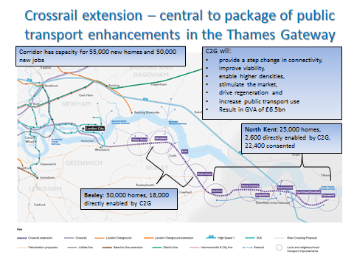

Special Note on Thameslink Services

The full Thameslink service network will be complete and in operation from December 2018 at the same time as the start of the new SERF. The introduction of a new Thameslink service to Kent, together with the transfer of another service from the existing franchise and the continuation of a third, will deliver a significant increase in capacity across the Kent rail network. The new SERF operator will therefore need to be fully informed of these proposals, both for the beneficial effect for passengers but also for the operating constraints they may have for the new SERF operator.

The table below summaries the new and retained Thameslink service network in Kent for 2018.

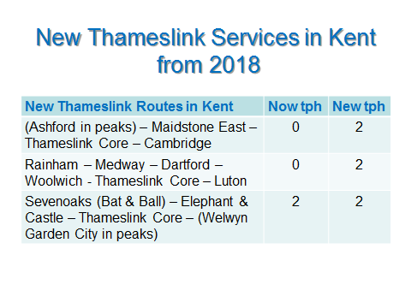

Conclusion

In the concluding remarks of the ‘Rail Action Plan for Kent’ (KCC, April 2011), the Council made this reference to the then forthcoming renewal of what was known as the ‘Integrated Kent Franchise’:

“The renewal of the Integrated Kent Franchise (IKF) in 2014 will be a pivotal moment in the provision of rail services in Kent. KCC intends to be at the forefront of the DfT’s stakeholder engagement process to ensure that Kent is offered the best possible rail service beyond 2014 within the budgetary and physical constraints available.

This Rail Action Plan for Kent (RAPK) will form the basis of KCC’s response to the DfT’s consultation on the new IKF, and we shall continue to consult with our own stakeholders and RUGs to ensure that as wide a range of opinion as possible will contribute to the final presentation of Kent’s case for the future of rail in the county.”

[Source: Conclusion, Rail Action Plan for Kent, KCC, April 2011]

Six years later these remarks remain absolutely true. KCC is indeed at the forefront of the DfT’s stakeholder engagement process, having taken up the offer from the Secretary of State for Transport for our Council to be represented in the new SERF competition team, influencing the determination of the service specification.

The Rail Action Plan for Kent has also substantially informed this response process. KCC has developed and enhanced several of the original proposals in the Rail Plan to reflect the changed demands and circumstances of the present day, while retaining the original intention of having a cohesive county-wide view of what the new rail service should deliver.

It is KCC’s view that the new SERF offers a unique opportunity to deliver a world-class, punctual, reliable, affordable and safe railway, meeting the increasing demands of a growing population, and providing the essential connectivity within Kent, and between Kent and London, for all those who need to travel by train.

County Hall
Maidstone
May 2017

KCC Response Author

Stephen Gasche
Principal Transport Planner – Rail
Transport Strategy Team
Kent County Council

stephen.gasche@kent.gov.uk

