Budget Consultation 2020-21 - Have your say on Kent County Council’s priorities

- Introduction
Kent County Council (KCC) provides a huge range of essential services. Some of these services, like repairing potholes and running libraries, are highly visible, others less so. KCC provides help and support to people of all ages who need it. We believe those services to the young, the elderly, the vulnerable and those with disabilities are a true test of a successful Kent community even though you or your family may not see them every day.

To help us ensure we spend the county’s finances on your priorities, we have three key objectives, known as our strategic outcomes. These set out the basic priorities for our spending:

- Helping children and young people in Kent get the best start in life.
- Kent communities benefit from economic growth by being in-work, healthy and enjoying a good quality of life.
- Older and vulnerable residents are safe and supported with choices to live independently.

Further information can be found in our strategic statement, Increasing Opportunities, Improving Outcomes.

We are in the process of updating our strategic outcomes for the next five years. We have already spoken to a number of Kent residents about what is important to them and what they want from their County Council. We will be consulting separately about this shortly.

Despite the relaxing of austerity by National Government, we are still unlikely to have enough money to fund all of the spending demands and sustain our current range of services. It is therefore more important than ever to spend our money wisely.

We have some big decisions ahead and value your thoughts before we take them. We’d like to hear your views on:

- Council Tax – is a modest rise acceptable if it helps to sustain the services you most value?
- The future of our services – are we focussing on the right priorities?
- Local Government in Kent
Kent is the most populated county in England with a population of over 1.5 million people (excluding Medway) and 630,000 households.

Local government in England operates under either a one tier system – unitary authorities or a two-tier system – county and district councils. Kent is a two-tier area, providing services for the whole county.

There are 12 district, borough and city councils in Kent, covering local areas. In addition, there are 316 parish and town councils for local communities and neighbourhoods. Medway Council is a neighbouring unitary (one tier) authority.

2.1 What services do we provide?
KCC provides over 300 services, such as:

Services for children, young people and families
- 84 children’s centres and early years services
- Supporting 1,594 children in care, and 1,703 care leavers
- Emotional wellbeing and mental health services
- Health visiting and child health checks
- Fostering, adoption and 10,000+ social work cases
- KCC travel saver and home to school transport
- Working with 583 schools on places, planning and access
- Special educational needs and disability including transport
- Apprenticeships, skills and career pathways for young people

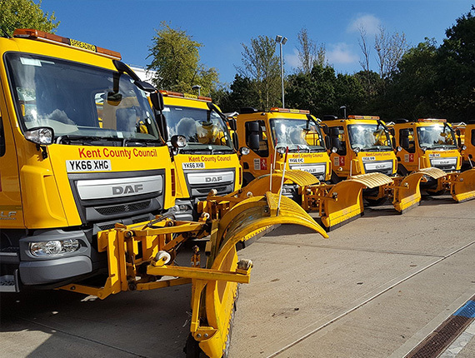
Services for all residents and communities
- Public health and wellbeing services
- Sports, arts, culture and heritage
- Highways, waste management and concessionary travel
- Active travel, public rights of way and country parks
- 99 libraries, mobile libraries and archives
- Community safety, emergency planning and trading standards
- Protecting the natural environment
- Registration and coroners' services
- Economic development and strategic planning

Services for older and vulnerable people
- Support for 4,878 adults with learning disabilities
- 4,140 permanent residential care placements
- Respite, safeguarding and support for 152,000 carers
- Support for 3,215 social care clients with mental health issues
- Support for 1,171 older people in nursing care homes
- Partnership working between health and social care
- 6,993 people receiving care and support at home
- Support for 5,335 adults with physical disability and sensory needs
- 2,363 people using day care services in their community

  - Where the Council spends its money
This chart and table show’s Council spending for 2019-20 (excluding schools). The numbers in the chart are explained in the table overleaf.
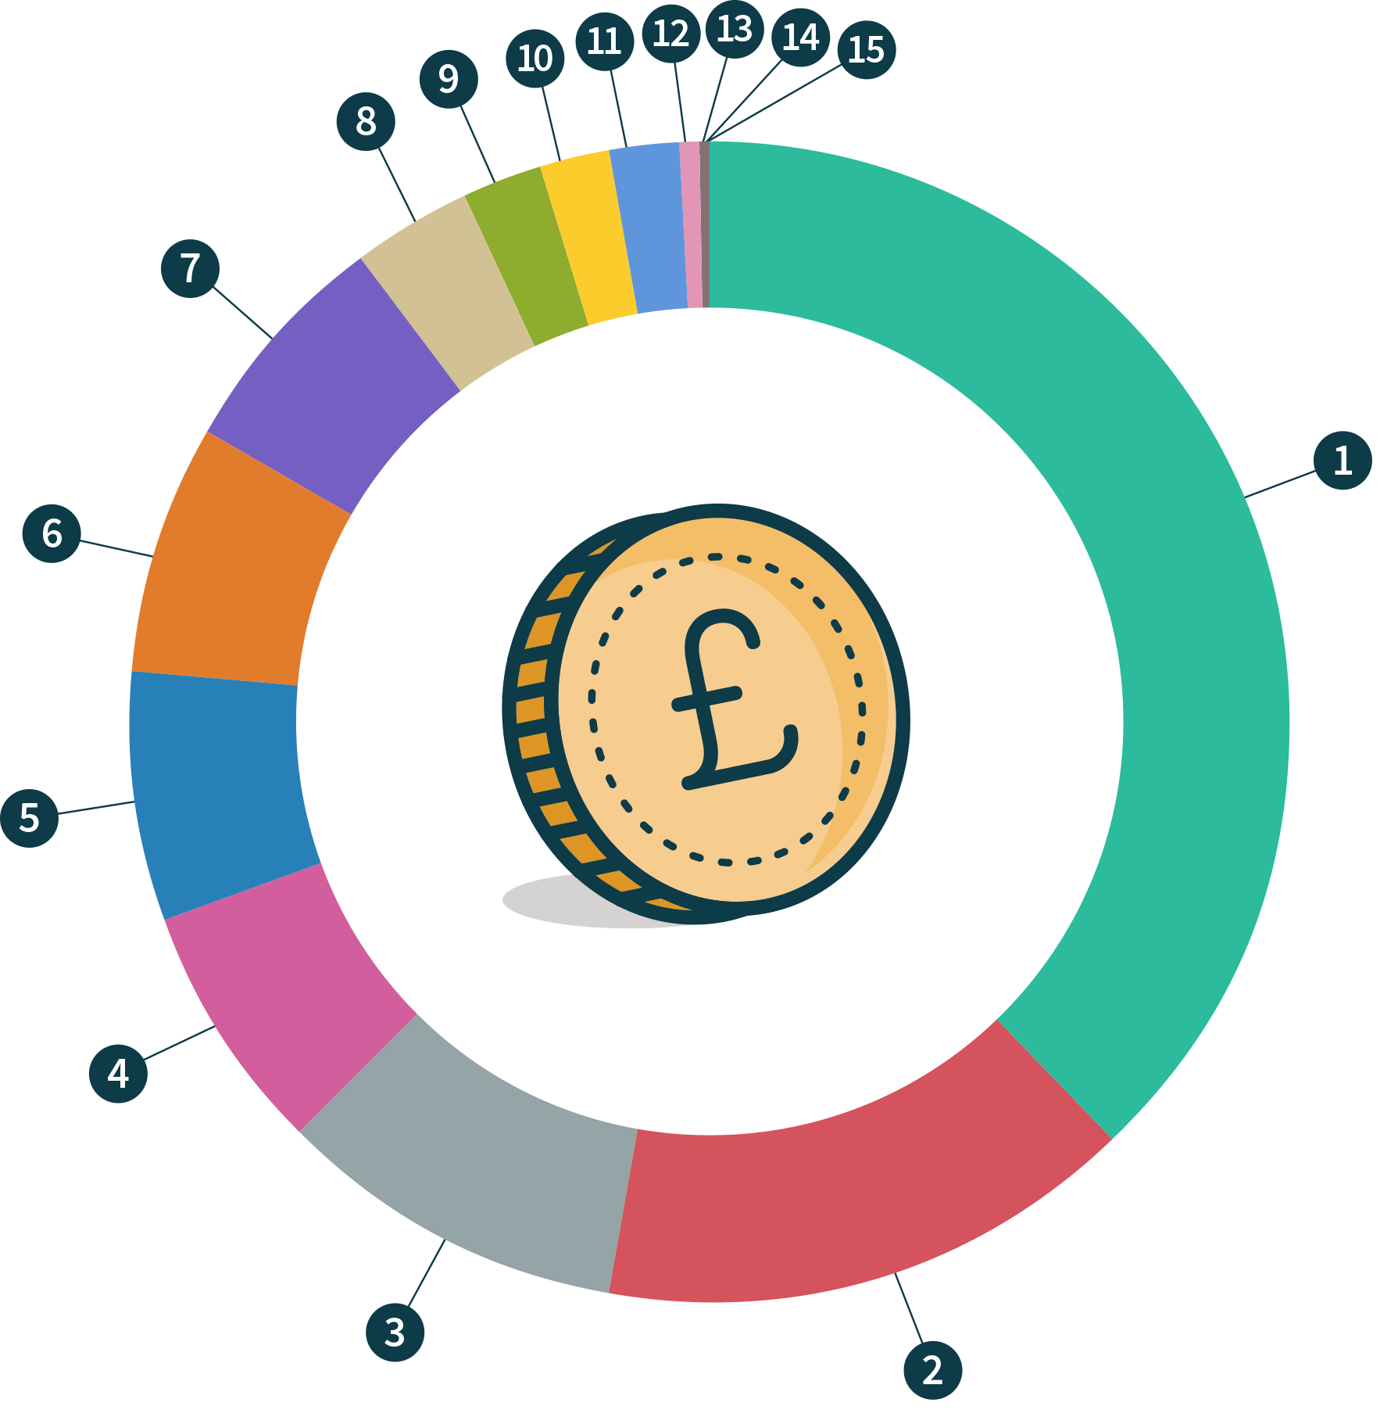

Service | Total spend (£m) | Total spend less income (£m) | Total spend less income (%)
- Adults & older people's services | 543.5 | 396.1 | 40.2%
- Children's social care | 187.7 | 155 | 15.7%
- Borrowing costs | 118.3 | 101.5 | 10.3%
- Waste management | 75.4 | 73.1 | 7.4%
- Transport services | 86.3 | 72.4 | 7.3%
- Management support & overheads | 94.2 | 69.4 | 7%
- Highways | 41.4 | 32.7 | 3.3%
- Children's others | 140.4 | 23.3 | 2.4%
- Costs of running our operational premises | 29.4 | 21.6 | 2.2%
- Other direct services to the public | 40.8 | 21.1 | 2.1%
- Community services | 36.9 | 14.6 | 1.5%
- Schools’ services | 20.6 | 3.7 | 0.4%
- Unallocated | 2.1 | 1.9 | 0.2%
- Public health | 68.5 | 0 | 0%
- School & high needs education budgets | 81.2 | 0 | 0%
Total | £1,566.7m | £986.4m | 100%

- The Continuing Challenge
You may have seen in the media how some councils have rapidly spiralled into crisis and now face cutting services to the bone just to stay afloat. KCC is not one of these authorities. We have always been careful with your money and taken some common-sense decisions to manage services wisely. This has been confirmed by our independent external auditors Grant Thornton who recently said, “the Council put in place proper arrangements to secure economy, efficiency and effectiveness in its use of resources”.

In some of the areas you tell us are most important to you we have even been able to increase investment and spending. However, there is no doubt, that we still face some tough decisions.

Next year we expect the Council’s budget to increase by up to £60m (6% of our net budget). This increase comes from a combination of an additional one-year grant from central Government, particularly to help towards social care pressures (although we will not know the final details for a couple of weeks) and from our proposals in this consultation to increase Council Tax by up to the 2% referendum level and levy a further additional 2% towards social care. We are pleased that the amount of money we will have in the next financial year is increasing, but the one-year settlement means that the future remains incredibly uncertain.

Most importantly the funding we receive is still not keeping pace with the additional costs and demand for our services. Taken together, this means there is forecast to be a budget gap in 2020-21 of between £18m and £22m. That’s a lot of money but KCC has an annual budget for services of over £1.5bn (excluding schools), and a proven track record of balancing the budget each year. We are confident we can resist some of the additional costs and demands, which will help to close the gap, but savings will still be needed to balance our budget.

3.1 Savings since 2011
We’ve saved £657 million since 2011, the chart and table show the areas where these savings have been made. The numbers in the chart are explained in the table overleaf.
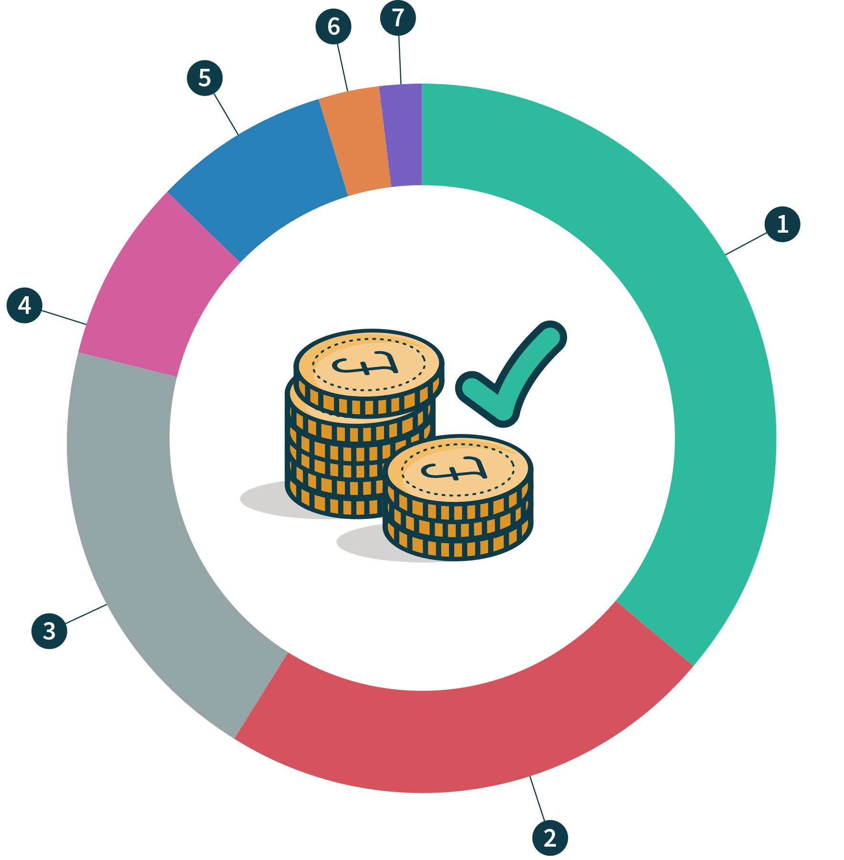

Areas savings have been made | Description | Saving amount (£m)
- Efficiencies | Service changes creating savings which have minimal impact on outcomes – doing the same for less | 238
- Transformation and service improvements | Part of a dedicated programme of changing service delivery – doing things differently | 149
- One off savings | Use of reserves | 133
- Policy savings | Local political choices involving a change in policy | 54
- Income from trading, clients and service users | Increased income due to changes in external charging and investment strategies | 52
- Borrowing savings | Savings predominantly from the review of debt financing costs | 20
- Public health savings to match grant reduction | Savings made within the public health service to match reduction in Government funding levels | 11
Total |  | £657m

- Setting Council Tax
The Government sets a maximum limit for Council Tax increases (without holding a referendum) and we expect the limit for next year to be just under 2%. We don’t wish to be a high tax council so that suits us too.

An increase of just under 2% would add £23.04 per year (or 44 pence per week) to the KCC element of the bill for a typical band C property and take the total KCC element of council tax to £1,178.08 (or £22.60 per week). Such an increase would raise £14.3m towards the council’s rising costs.

- Social Care Levy
In 2016, Government introduced a Social Care Levy, which allows councils with adult social care responsibilities like KCC to raise Council Tax a little further in return for a guarantee to spend it only on those services. Since KCC already has a commitment to provide the best possible services for the most vulnerable people in society, it was a deal we were ready to sign-up for and in last year’s consultation we asked you whether you were prepared to pay a little extra Council Tax for it. We are asking the same question this year.

KCC is proposing to levy a 2% social care increase in 2020-21. This would raise an additional £14.3m to be spent on adult social care services and increase the KCC element for a band C property by a further £23.04 (or 44 pence per week). This would make the final estimated band C bill, after the social care levy, to be £1,201.12.

So, when KCC sets its budget in February 2020, it will need to consider whether Council Tax should rise to the referendum level (currently just under 2%) and whether the Social Care Levy should also apply.

We all face a big question. Do we want to carry on providing good care to the young, elderly, the vulnerable and those with disabilities and are we, as Kent residents, willing to pay more for those services?

We believe that the public services KCC provides (particularly social care) are a benchmark of a responsible society, but Kent residents have a right to have their say.

- Looking Ahead - big decisions are still needed
Every year, KCC must agree an annual budget, which balances the money we spend, with the money we have. That means that the money we receive from: Council Tax; a proportion of business rates and government grants; income we generate from things like bus passes and from our successful Kent Commercial Services, must balance with what we spend. It is possible to top-up with money from reserves but of course, that’s not sustainable as you can only use your reserves once.

Having our strategic priorities, Increasing Opportunities, Improving Outcomes has helped us protect these ‘front line’ services, but naturally means that spending reductions have fallen more heavily on other areas. We try to tackle this by doing the same job for less money (efficiency) and by doing a better job by doing things differently (transformation). Whilst it’s good to avoid ‘buzzwords’ these are a useful shorthand for the different approaches we have taken to meet the challenge without reducing core front-line services.

Even so, the financial challenge we face mean we cannot always promise to protect some of the services that you (and we) feel to be important. That’s why it’s important for us to understand what matters most to Kent residents.

- Your Views Matter
We want to be as up-front and transparent with you as possible. Your input helps us make decisions, and we hope you can understand the pressures and decisions we face.

With an annual expenditure budget of over £1.5bn, over 300 services and more than 1.5 million residents to serve our budget is complex.

Our aim is to ensure that you have the information available to help us tackle these big decisions together and encourage more transparency and involvement from taxpayers and service users when we set our budget.

The consultation runs until 25 November 2019. To take part, please visit our website www.kent.gov.uk/budget and complete the online questionnaire.

Completing the questionnaire online helps us to make the best use of our resources. Public computers are available from Kent libraries for you to use. However, if you are unable to take part online a hard copy of the questionnaire can be requested via our Alternative Formats team: email alternativeformats@kent.gov.uk or call 03000 421553 (text relay service number: 18001 03000 421553). This number goes to an answering machine, which is monitored during office hours.

Consultation responses will be considered by Councillors at their Cabinet Committee meetings taking place throughout January 2020 before the budget is debated at and approved by County Council in February 2020.

