Body Map – This can be printed or photocopied as required. (It is possible to type into electronically but not to highlight the affected area’s )

Adult’s name: Date of birth: Case number:
Address:

Right Left Left Right

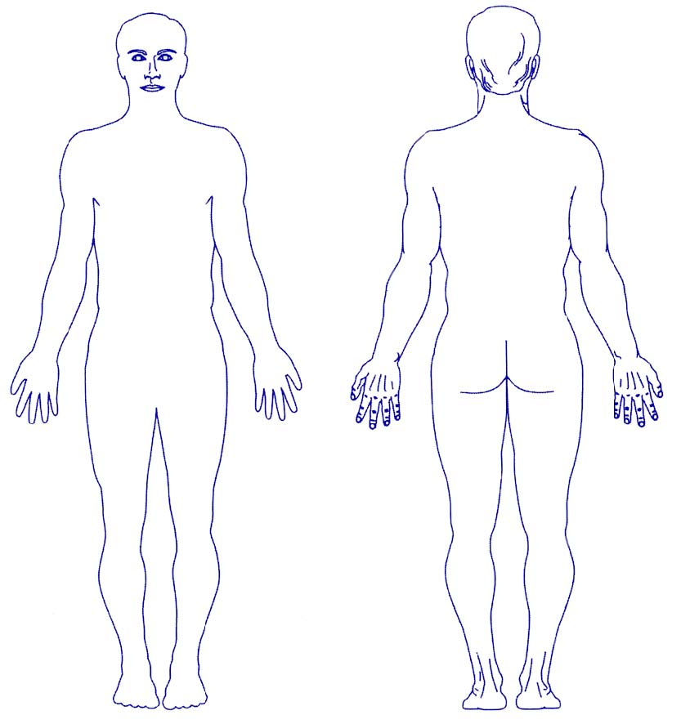

Please mark any noticeable marks that you may have seen on the body of the adult giving rise to this concern .Please describe injury(ies)

Date: Time: Name of person completing this form:
Signature: Position:

